Contents

HTML

CSS

CSS Properties

Why is CSS called as Cascading style sheet?

Combining CSS Selectors

CSS Positioning

CSS Display

CSS Float:

How to create responsive website:

Media Query:

CSS FLEX:

Flex layout

Flex Properties Notes/Summary:

Flex Sizing:

CSS GRID

Grid Sizing:

Grid Notes:

DEV TOOLS

GRID Placement:

Note: Grid property on items:

Grid Exercise:

Bootstrap

When to use bootstrap or external CSS framework and when to not.

Bootstrap Layout

Bootstrap layout Exercise:

Bootstrap Notes:

Introduction of Web Design

Some useful cites:

JavaScript

Collections:

Loops:

Javascript to Websites:

Document Object Model (DOM):

Separation of Concern:

JQuery

The Unix Command Line

Some unix commands

Node.js

Definition:

NPM – Node package Manager:

ECMAScript Modules

Express:

HTTP Request:

HTTP response status codes

Introduction to Middleware:

EJS: Embedded JavaScript

EJS Tags:

Passing data to EJS Templates:

EJS Partials and Layouts:

GIT

Git commands:

GitHub and Remote Repository:

Git Ignore:

Git clone:

# **HTML**

Community: https://discord.com/channels/743099782431637545/826143369201713192

**Hyper text mark up language**

1. To work on web development and learn HTML, CSS, JavaScript, React, bootstrap download:

Visual Studio Code and some extensions like:

<https://marketplace.visualstudio.com/items?itemName=ms-vscode.live-server>

<https://marketplace.visualstudio.com/items?itemName=esbenp.prettier-vscode>

<https://marketplace.visualstudio.com/items?itemName=vscode-icons-team.vscode-icons>

and Chrome browser.

In Chrome browser need extension like:

React developer tool

Pesticide for chrome

1. To learn more about html tags go to:

<https://developer.mozilla.org/en-US/docs/Web/HTML/Element/Heading_Elements>

1. To generate testing text in web design use below website:

<https://www.lipsum.com/>

or google for funny lorem ipsum

1. To check difference:

<https://www.diffchecker.com/>

1. Some html tags:

**Header** ->

<h1></h1>

<h2></h2>

<h3></h3>

<h4></h4>

<h5></h5>

<h6></h6>

**Paragraph** -> <p></p>

**Self-closing or Void element** :

Horizontal rule: <hr/> or <hr>

The line break element: <br/> or <br>

**The List Element:**

Unordered List:

<ul>

<li></li>

<li></li>

</ul>

Ordered List:

<ol>

<li></li>

<li></li>

</ol>

Nesting and indentation:

<ul>

<li></li>

<li>

<ol>

<li></li>

<li></li>

</ol>

</li>

</ul>

**The Anchor Element**

<a href=”url”></a>

**The Image Elements**

<img src=”url”/>

Note: <https://picsum.photos/> can be used to pic some pictures for feeling the look and feel of a pic

1. **Computer File Path:**

Absolute and relative path.

Absolute path : Path from root element is absolute path. Eg. C://someFolder/someFolder2/File1

Relative path: Path from the location you are accessing the resource. Like in the image :

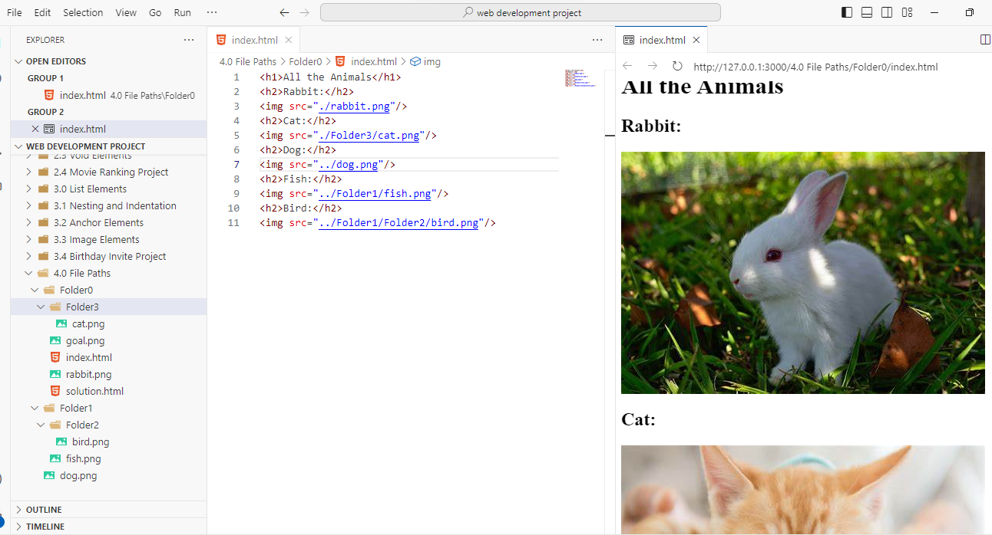

I am trying to access images from the index.html file so relative path will be the path from the location of index.html, here it is folder0 as it contains index.html,

So, to get rabbit.png I can use “./rabbit.png” as the file is present in same folder, used single dot.

for getting cat, again it’s in same folder so use “./folder3/cat.png” , used single dot.

To locate dog file we need to go a folder up so use “../dog.png”, used double dots.

To locate fish file, we need to go a folder up, so use “../Folder1/fish.png”, used double dots.

1. What are Web-Pages?
2. The HTML Boilerplate.

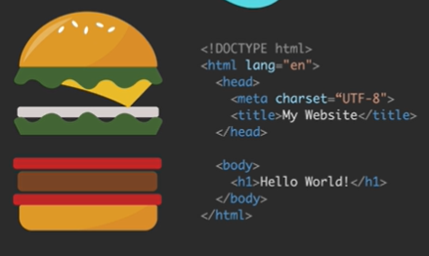

Shortcut to generate HTML Boilerplate in VS Code is to remove every thing from HTML file and Press ! and enter.

1. How to host your website for free with Github.

Copy all content of the web-project to new repository, commit changes, goto settings – choose pages -> under Branch choose main and /(root) save changes and refresh to get something published similar to :

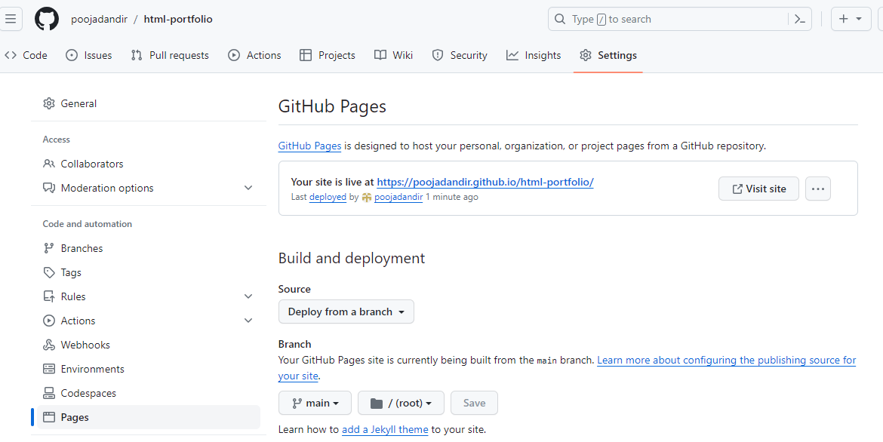

# **CSS**

**Cascading Style Sheets**

Ways to use CSS in our websites:

1. Inline -> 1 html element

<tag style=”css”/>

Example : <html style=”background:green”></html>

1. Internal -> 1 html page

<style>css<style/>

1. External -> 1 website

<link href=”style.css”/>

Ex: <link rel="stylesheet" href="./style.css" />

**CSS Selector:** This helps us to apply CSS property: value to particular tag.

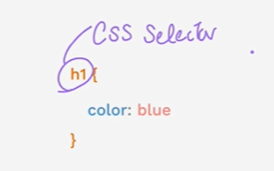

1. **Element Selector:**

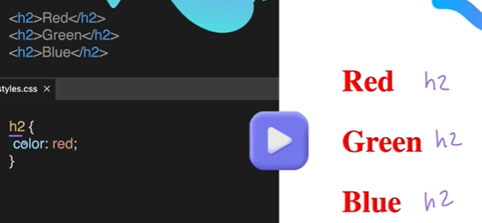

1. Class Selector:

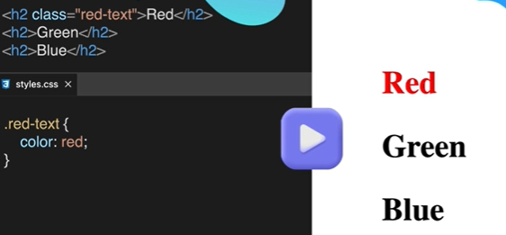

1. Id Selector

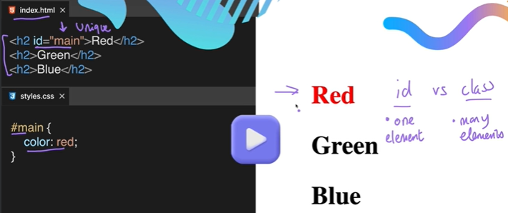

1. Attribute Selector:

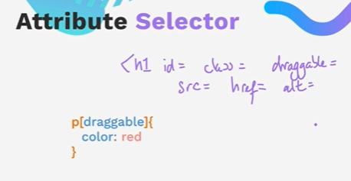

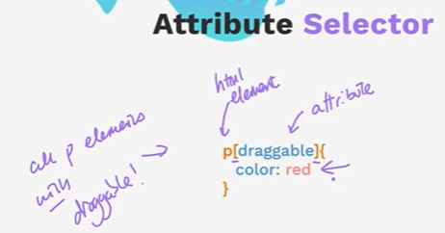

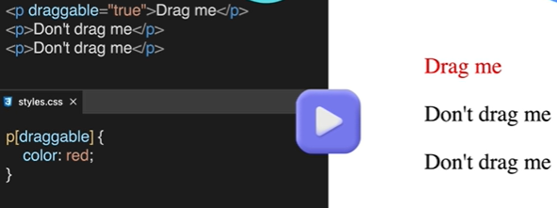

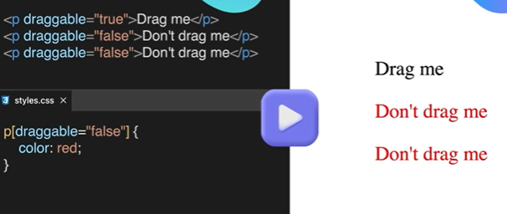

1. Universal Selector:

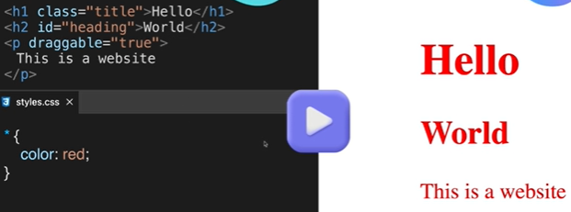

## **CSS Properties**

1. **Color**

[**https://developer.mozilla.org/en-US/docs/Web/CSS/named-color**](https://developer.mozilla.org/en-US/docs/Web/CSS/named-color)

[**https://www.csfieldguide.org.nz/en/interactives/rgb-mixer/**](https://www.csfieldguide.org.nz/en/interactives/rgb-mixer/)

[**https://colorhunt.co/**](https://colorhunt.co/) **for choosing different color combinations**

1. **Font properties**

**https://fonts.google.com/**  if want to use different fonts.

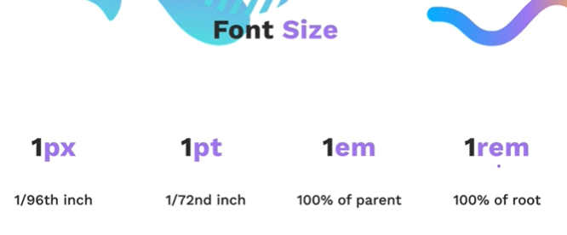

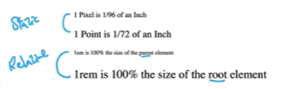

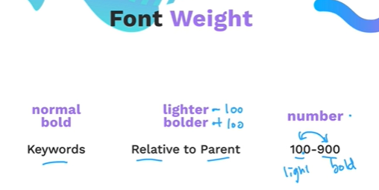

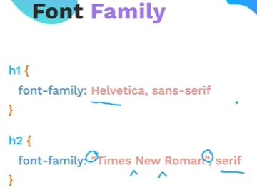

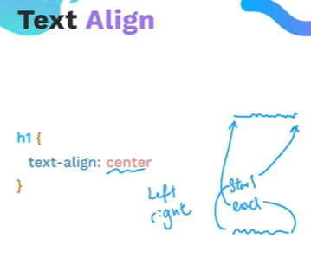

**CSS box Model:**

* Margin
* Padding
* Border

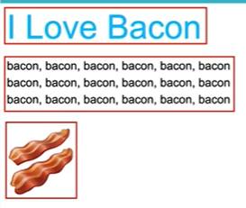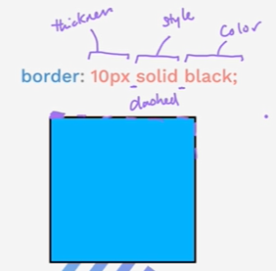

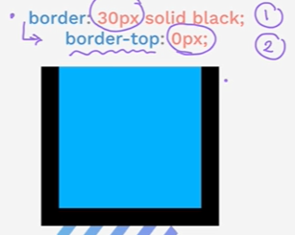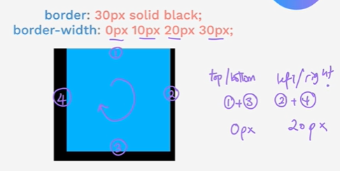

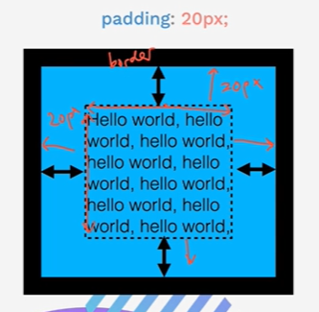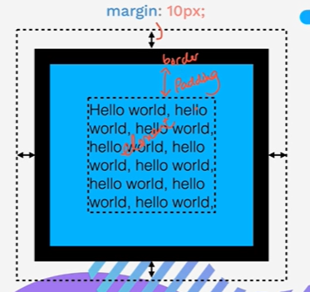

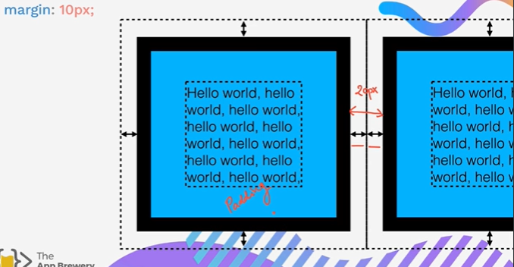

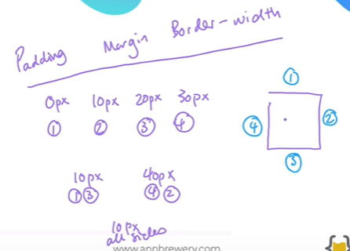

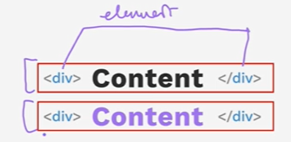

## **Why is CSS called as Cascading style sheet?**

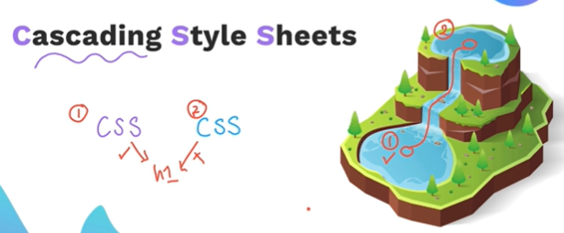

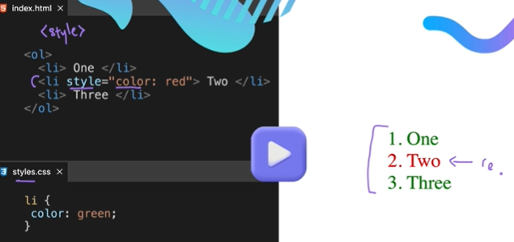

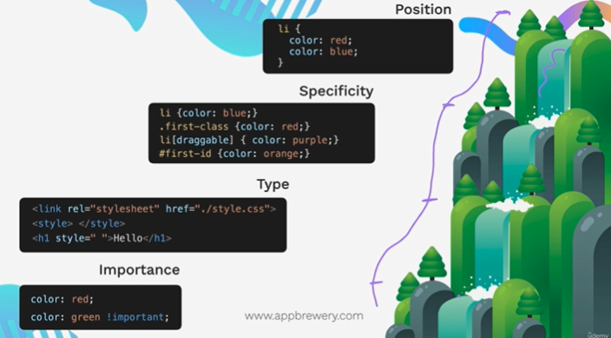

Because of Position, Specificity, Type or importance of the CSS style.

1. Position

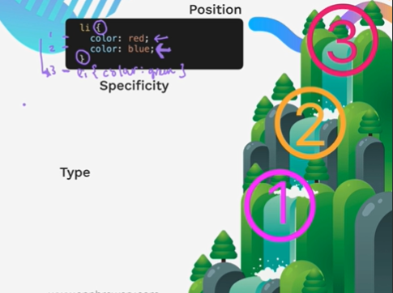

1. Specificity:

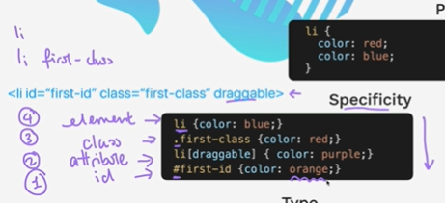

1. Type

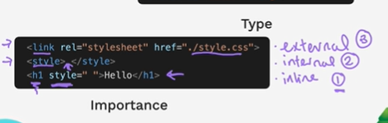

1. Importance

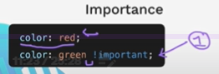

## **Combining CSS Selectors:**

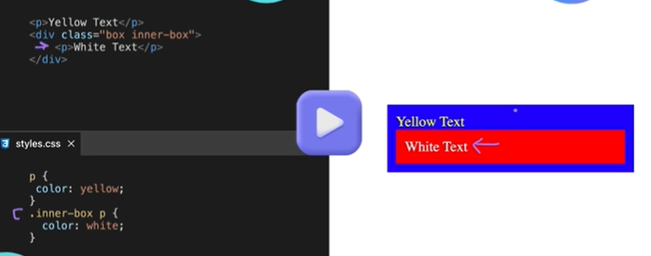

1. **Combining by Group: ex h1, h2{color:blue;}**

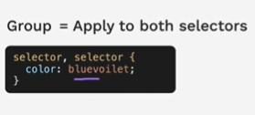

1. **Combining by Child: ex div >div {color: red;}**

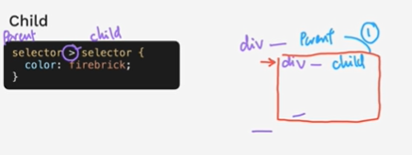

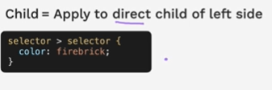

1. **Descendant: .class1 .class2{color:red;}**

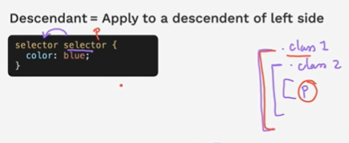

1. **Chaining: goto very specific element**

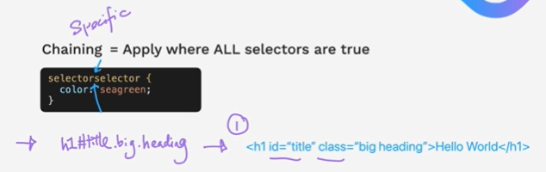

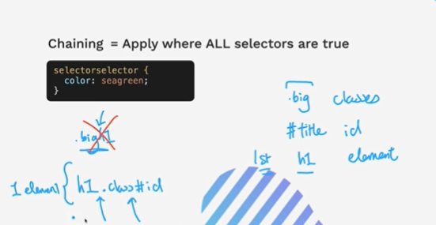

1. **Combining Combiners:** ex. Ancestor chaining

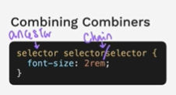

## CSS Positioning:

Relative, Absolute, Fixed and Static Positioning

https://appbrewery.github.io/css-positioning/

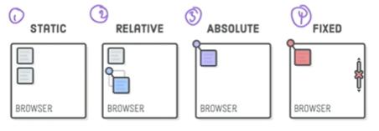

1. **Static position**: html default flow.

Content will come next to each other like image 1.

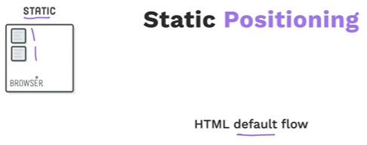

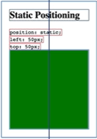

1. **Relative position:** relative to it’s default position. Like 200px top and 200px left of it’s default position as show in image 2.

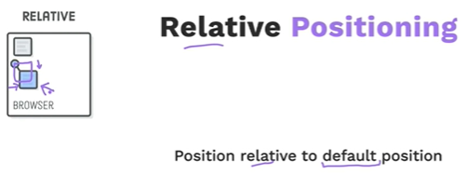

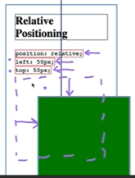

1. **Absolute position:** relative to its parent position.

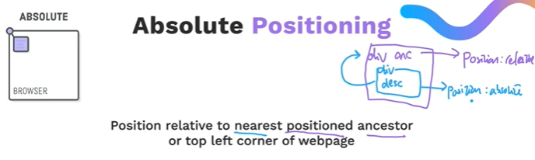

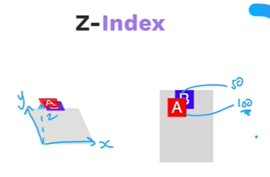

1. **Fixed position:** fixed to browser.

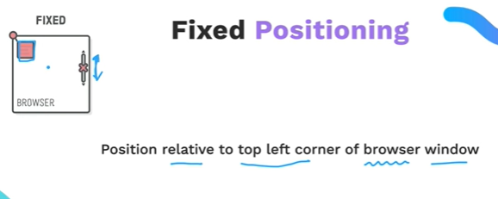

**Note: Position is separate from margin or padding .**

**Example website created in CSS:**

<https://pattle.github.io/simpsons-in-css/>

<https://diana-adrianne.com/purecss-lace/>

## **CSS Display:**

There are three common types of display values: (there are many many values for display though, these are commons once)

https://appbrewery.github.io/css-display/

1. **Inline**: We can’t set the height or width of element if it’s display is set to inline.

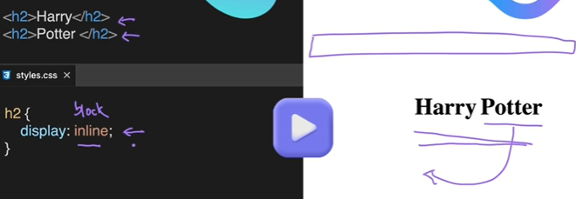

1. **Block**: default

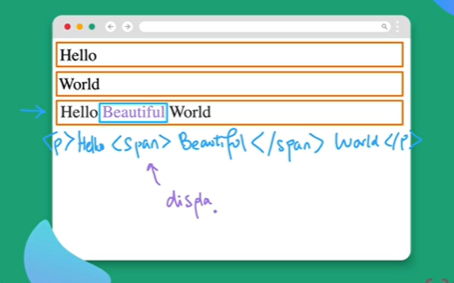

1. **Inline-Block**

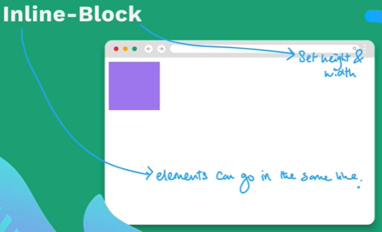

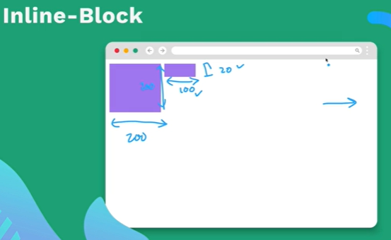

1. **None:** With this value set for display property, the element will disappear.

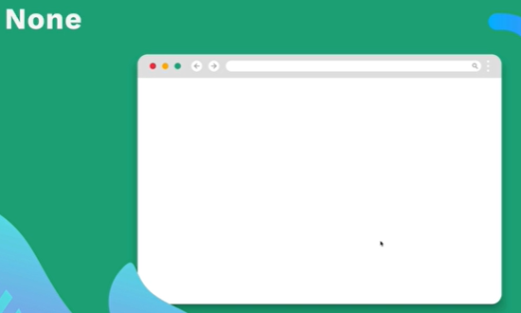

CSS Float:Use it only to wrap text around images.

float:left; -> applied on element we want the other element to be floating around on.

float:right; -> same as above.

clear:left; -> applied on element which we don’t want to be floated around the float element.

clear:right; -> same as above.

clear:both; -> same as above.

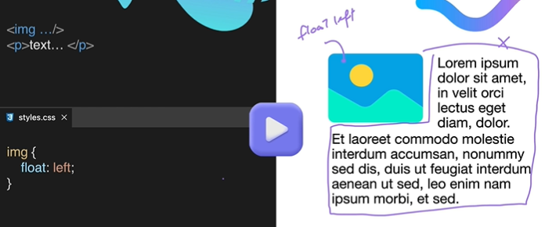

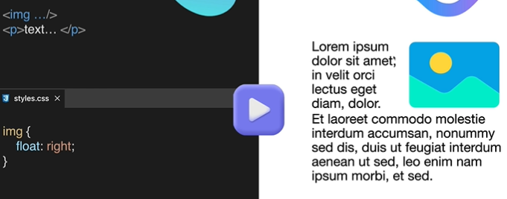

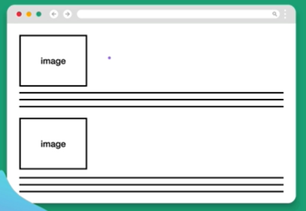

to ->

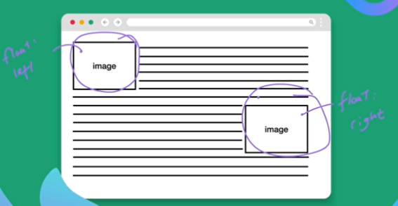

How to stop float for some element like footer as image keeps the float property not the text around it:

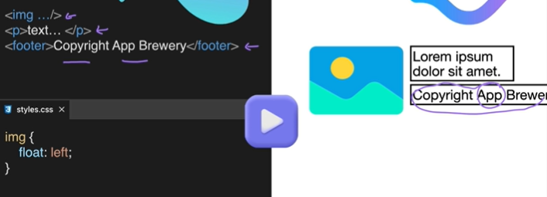

To ->

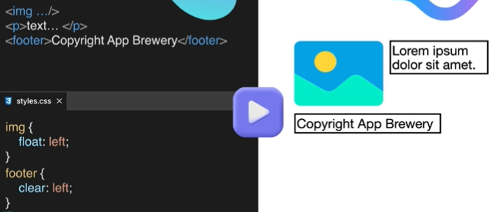

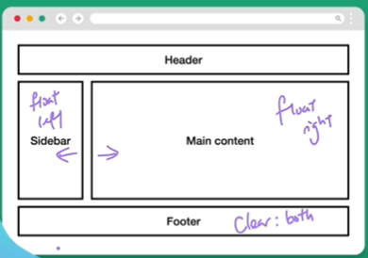

Note: to achieve layout something like above we have some other easy stuff to be used instead of float.

# **How to create responsive website:**

Making websites look good on all screen sizes. Desktop, laptop, tablet, mobile.

There are 4 main ways to do it.

1. Media Queries
2. CSS Grid
3. CSS Flexbox
4. External frameworks e.g., Bootstrap
5. Media Queries:

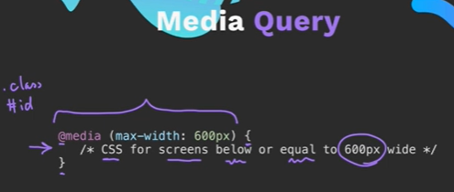

1. CSS Grid

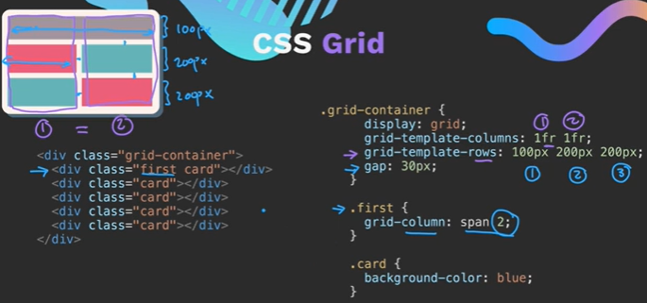

1. CSS Flexbox:

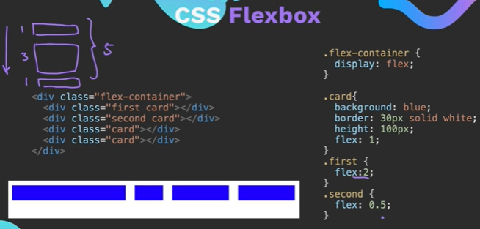

1. Bootstrap Framework:

It is built on top of CSS flexbox. And since it is built outside of CSS, it’s a framework. Works on 12 segments.

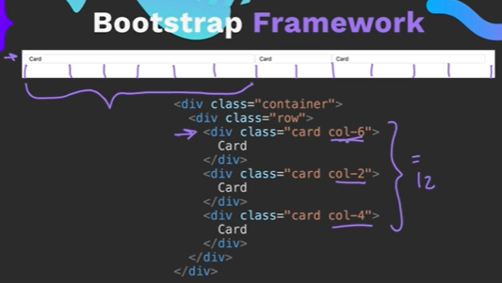

## **Media Query:**

@media(max-width: 600px) – small screen, @media(min-width: 600px) – big screen

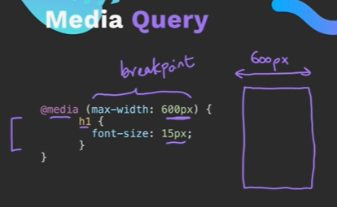

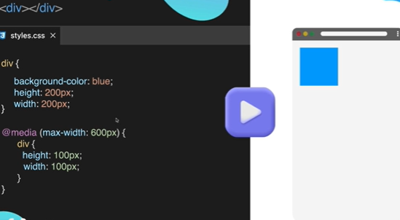

Combine media:

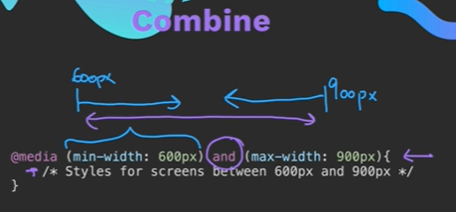

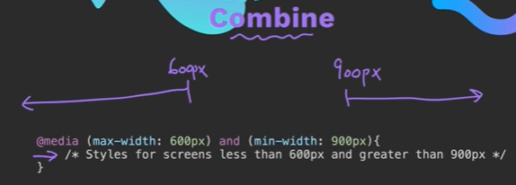

Use of screen with media is not recommended.

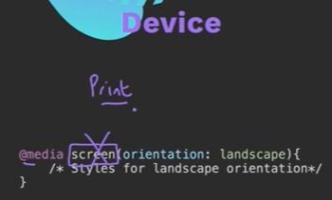

How to test responsive websites:

Got to chrome dev tools -> toggle device tool bar

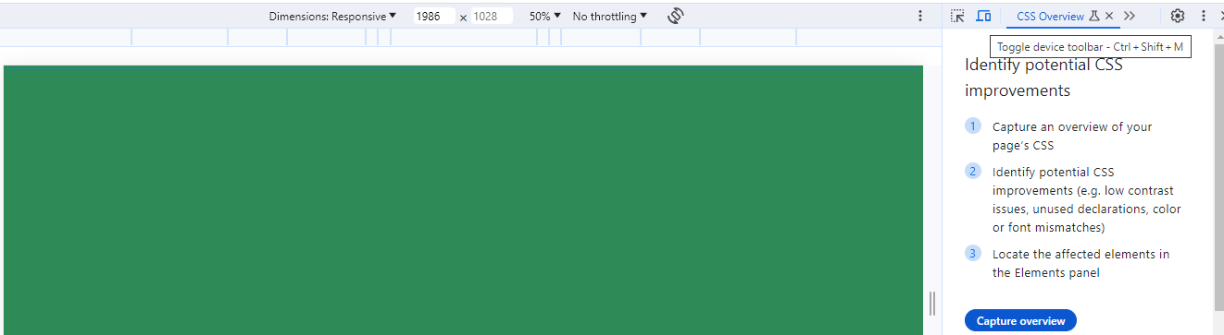

## **CSS FLEX:**

Older way to design wegpage: now not recommended

Way 1: using html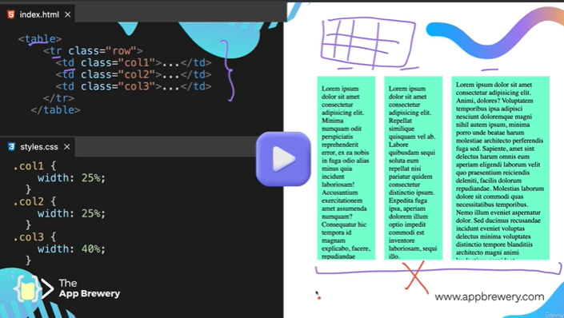

Way 2: using positioning:

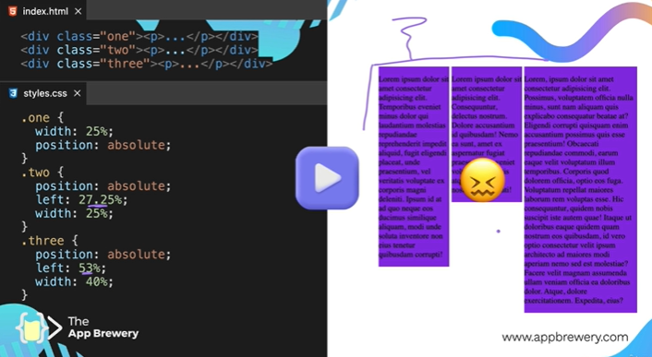

Way 3: Better way: most used in 2005 – 2010 era: using Float, but a no no now

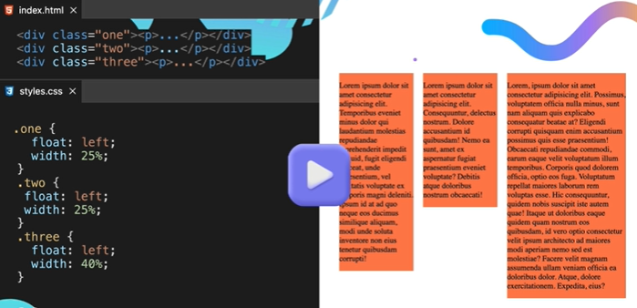

Flexbox, grid, bootstrap are recommended way to give this kind of layouts:

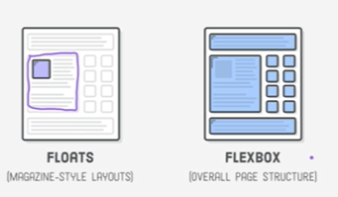

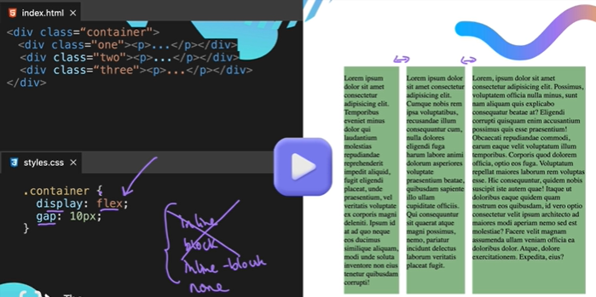

By default:

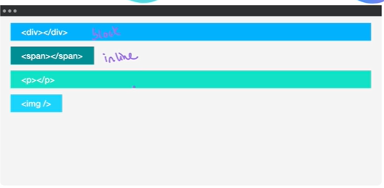

With **display: flex ->** next item will be in the next block, a property on parent

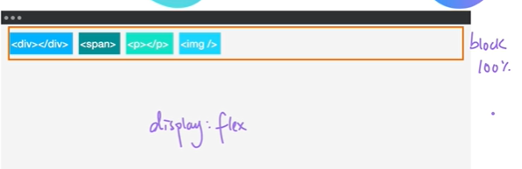

**display: inline-flex:** Each item will take only the space need to fit. and set next items if any to next to last element in same row. A property on parent

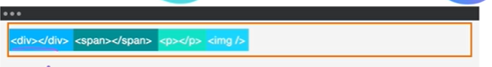

To apply flex on elements we need to set the display property to flex or inline-flex on the container whose element we want layout to.

Example:

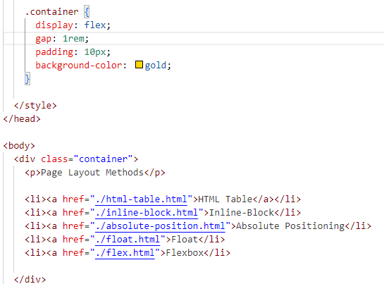

Flex-direction: row -> default, a property on parent

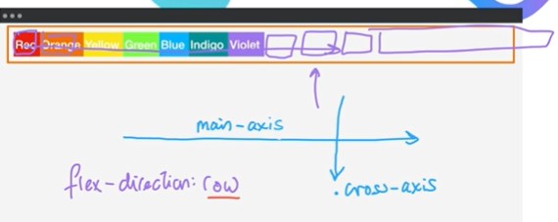

Flex-direction: column -> property on parent

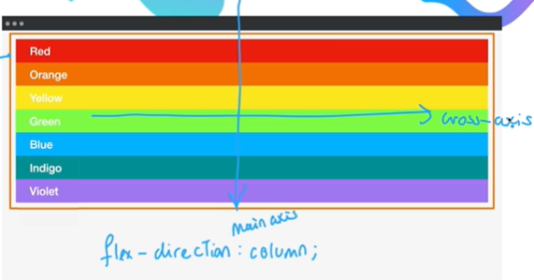

flex-basis: 100px;

### **Flex layout**

Align, Justify, Wrap

**Order property:**

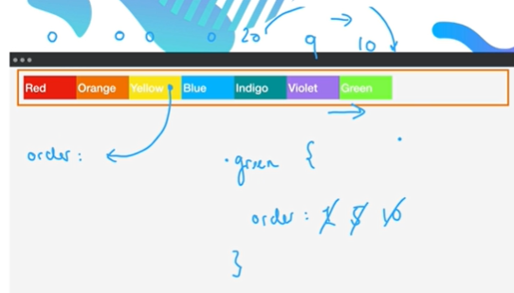

**Wrap property:** it is a container property

Default : flex-wrap: nowrap; if any item goes beyond the row length, it won’t be displayed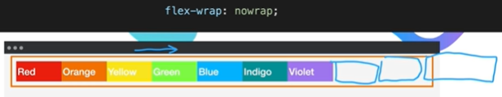

Flex-wrap: wrap

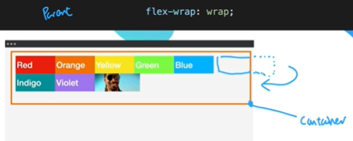

<https://appbrewery.github.io/flex-layout/>

justify-content: flex-start; set on parent i.e. container

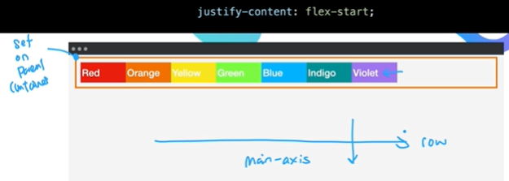

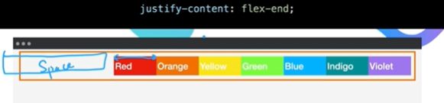

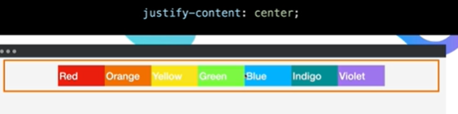

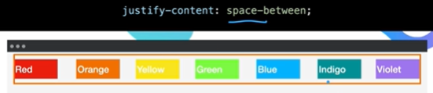

Align-items: flex-start; property is set on container

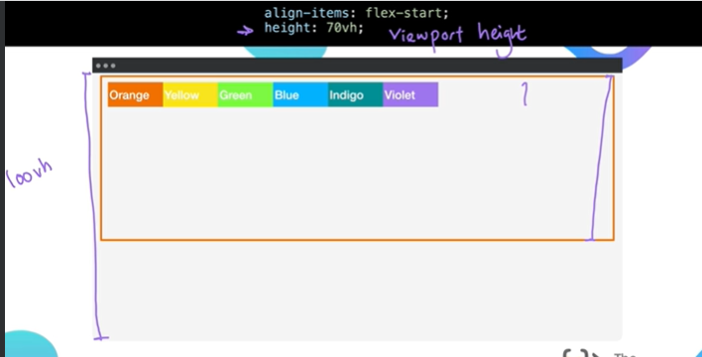

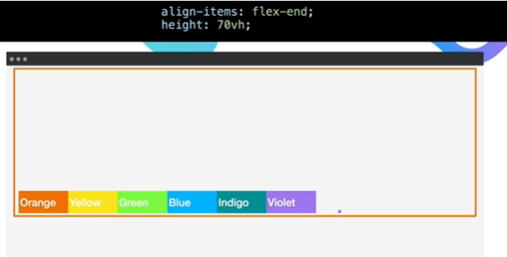 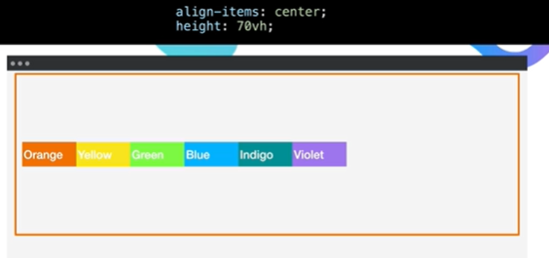

Align-self: property set on item in the container.

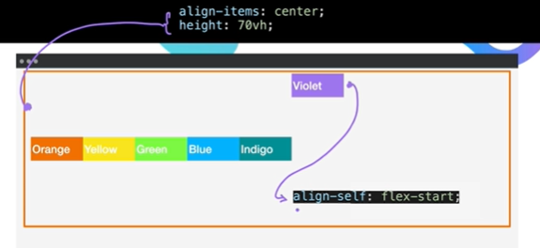

**Cheat sheet link:** <https://css-tricks.com/snippets/css/a-guide-to-flexbox/>

**Align-content**: used when flex-wrap is set to wrap

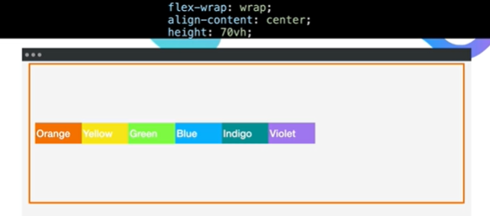

**Assignment:** <https://appbrewery.github.io/flexboxfroggy/> flex frog learning and practicing game.

<https://flexboxfroggy.com/>

### **Flex Properties Notes/Summary:**

Container is must in flex

Display:flex

justify-content

align-items

flex-direction

order

align-self

flex-wrap

flex-flow

align-content

order: num

Property value:

Direction – row, row-reverse, column, column-reverse.

Alignment and justify content – flex-start, flex-end, center, (for justify – space-between, space-around) (stretch for align-content, which work only for wrap)

Flex-wrap – wrap, nowrap, wrap-reverse.

Flex-flow – combine flew-direction and flex-wrap as :row wrap

### **Flex Sizing:**

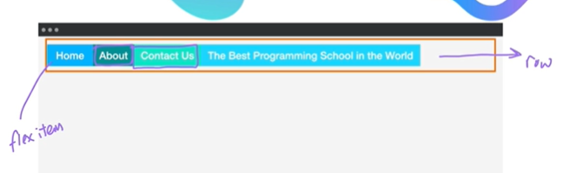

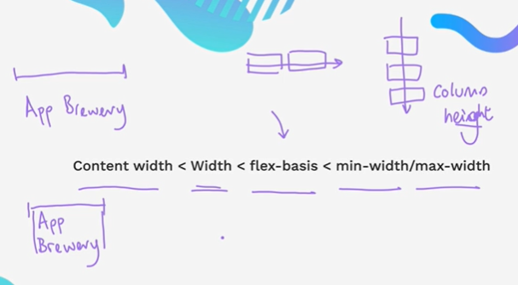

Default behavior:

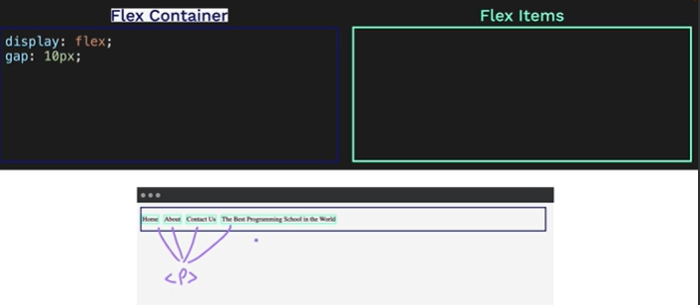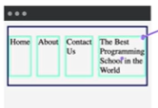

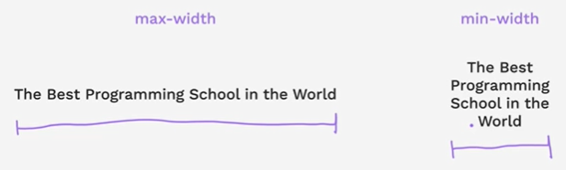

After setting width in css: works till width is available on page, then ignore it. And behave default.

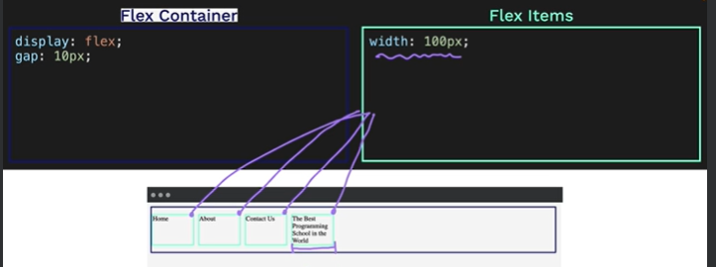

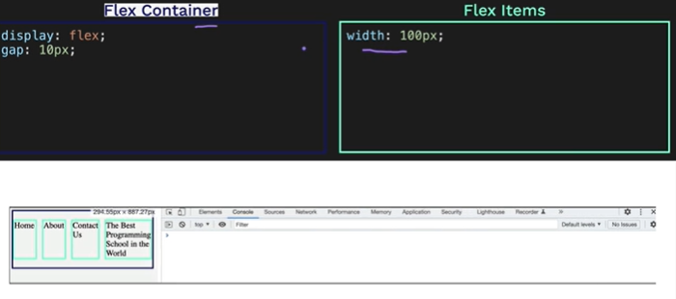

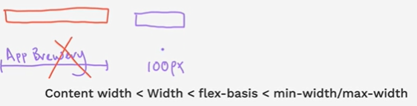

Set flex-basis: it ignores previously set width. Behave default after it reaches out the limit set.

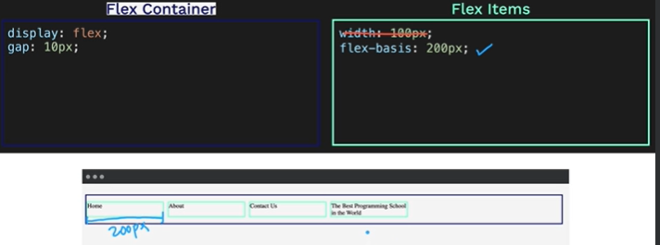

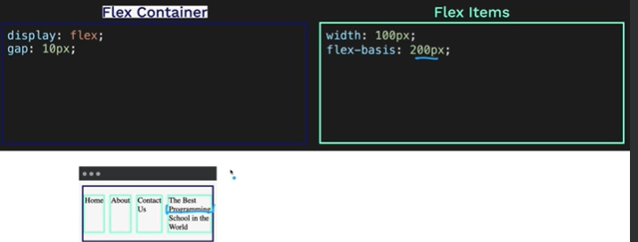

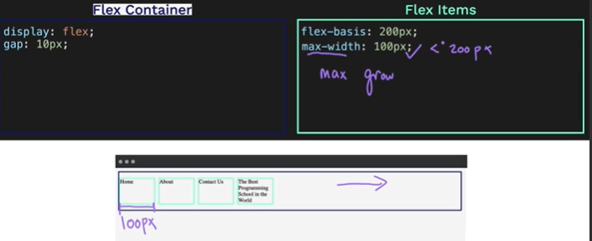

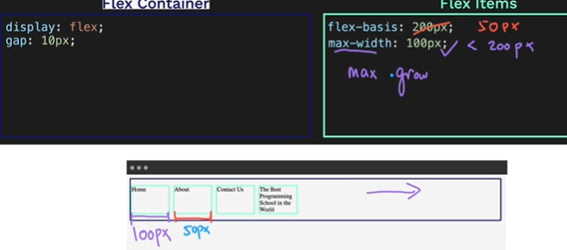

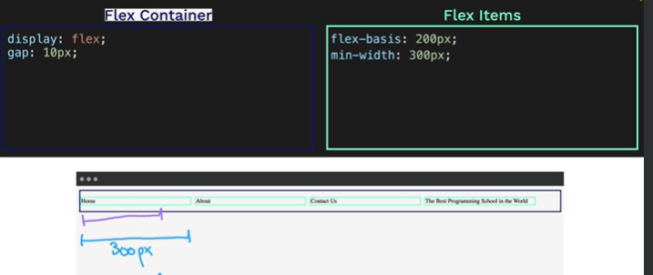

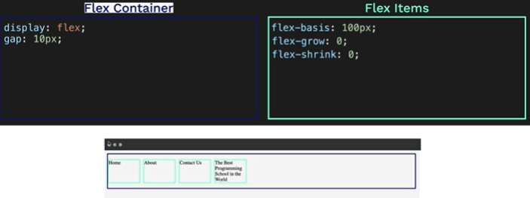

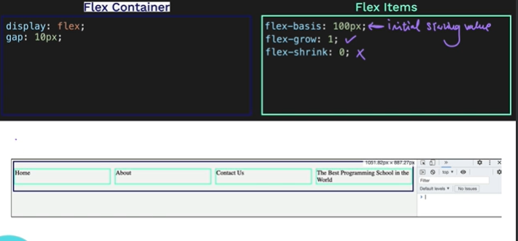

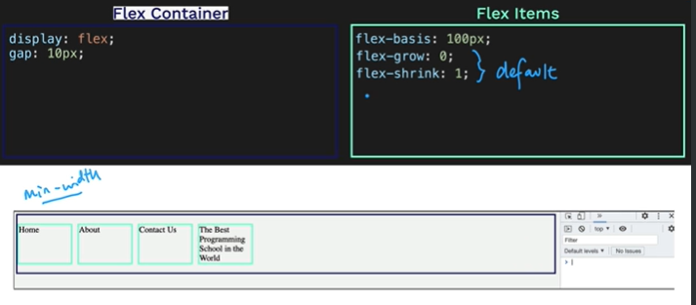

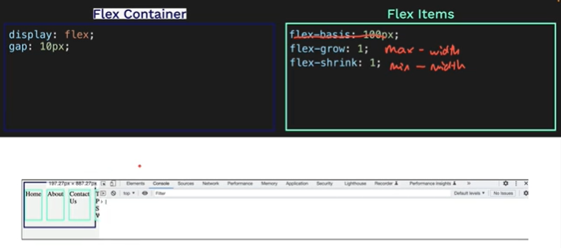

Flex: 1 1 0; is so common that we can short hand it to only flex: 1;

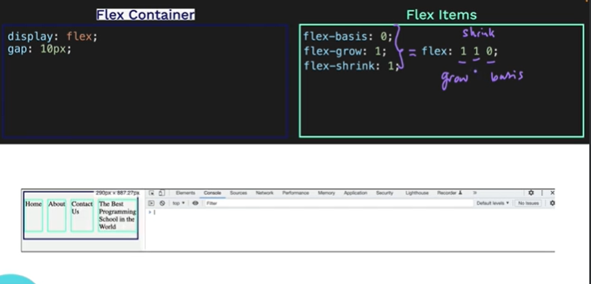

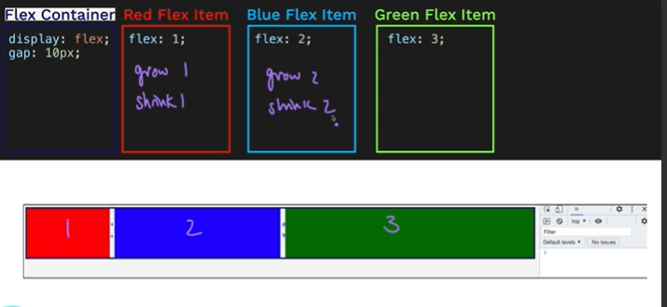

<https://appbrewery.github.io/flexbox-sizing-exercise/>

## **CSS GRID**

A two-dimensional layout system

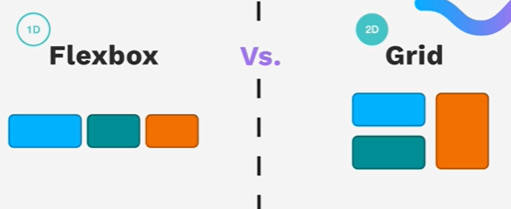

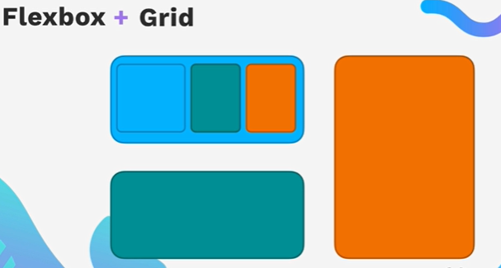

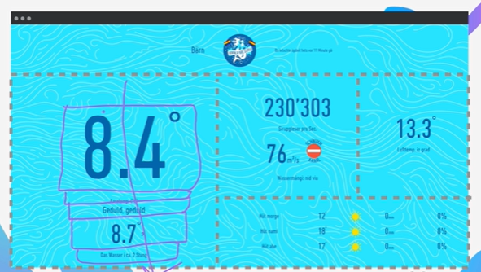

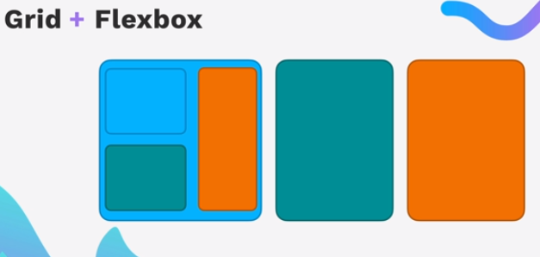

We can have flexbox inside a grid or grid inside a flexbox.

<https://appbrewery.github.io/grid-vs-flexbox/>

How to apply grid: fr means fraction. Using fraction for sizing make grid responsive.

### **Grid Sizing:**

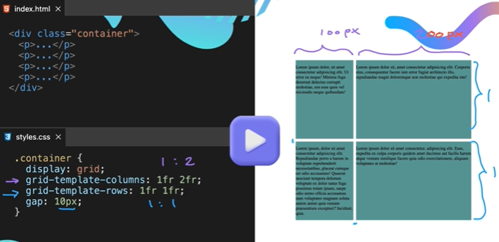

If we fix the size of row and column like below in grid, then it will become no responsive. Nor using 1 rem 2 rem will help here.

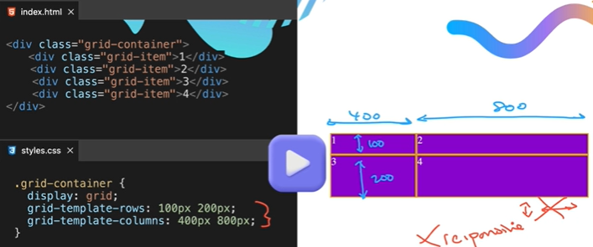

It can also be represented as:

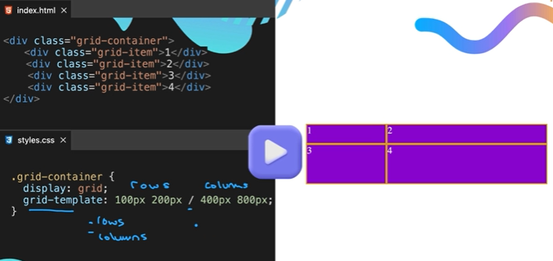

To get little bit of responsiveness we can use auto as: so in case of column here second one is set to auto so it will take 100% of screen and adjust responsively, while in case of rows it will use content to fit auto instead of screen. Fig below are examples of it.

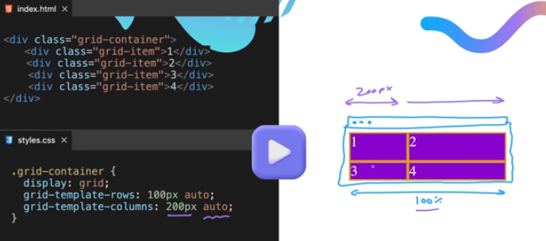

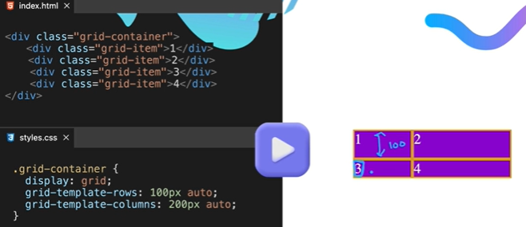

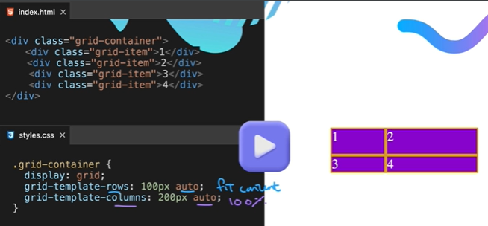

Minmax() in grid used to give min and max size to item in a grid.

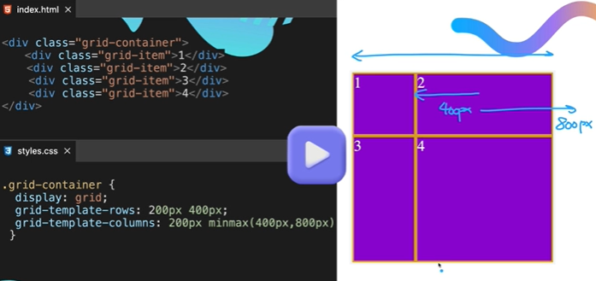

Repeat(times, size) -> repeat(2, 100px)

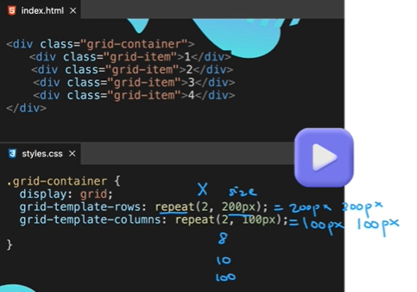

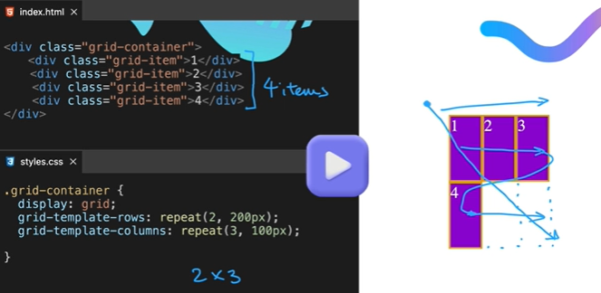

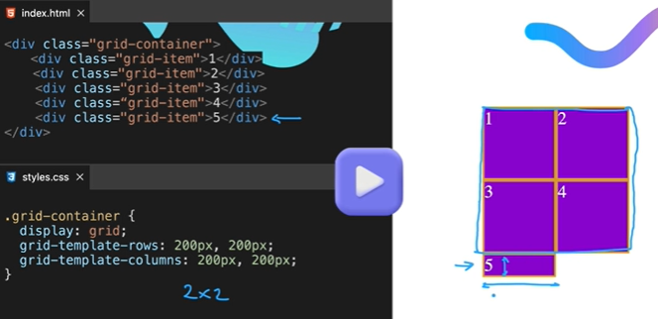

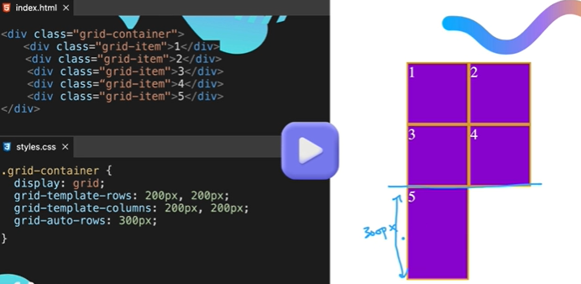

### **Grid Notes:**

Container is must in grid

display: grid;

grid-template-columns;

grid-template-rows;

grid-template; ---- row/columm

grid-auto-rows

gap: num;

values:

fr -fragments

px

auto

minmax(v1, v2);

repeat(times, size);

### **DEV TOOLS**

Using Chrome developer tool

Ctrl + shift + I short cut to chrome developer tool

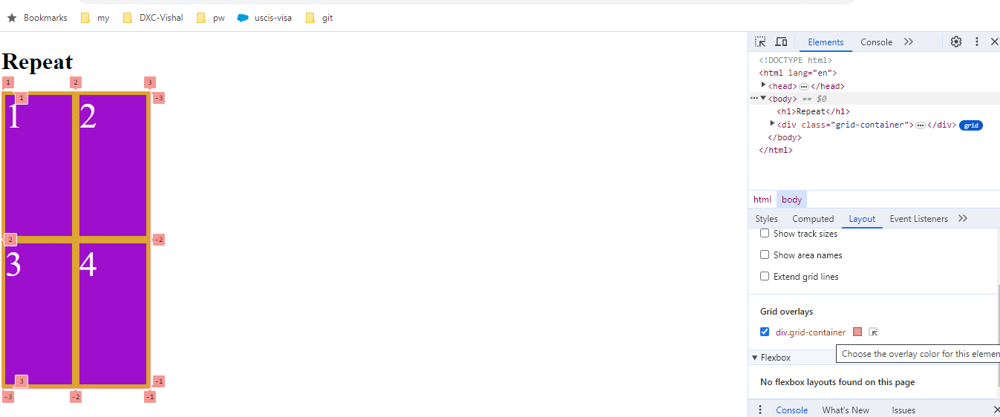

### **GRID Placement:**

How to layout items in the grid

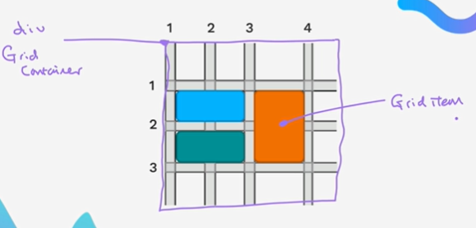

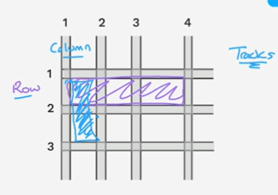

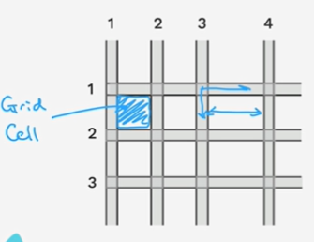

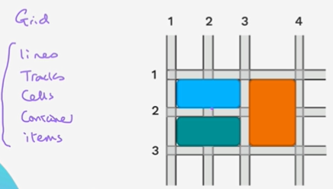

The grid lines, tracks (row or column), cells, container, items are common words to do grid placements.

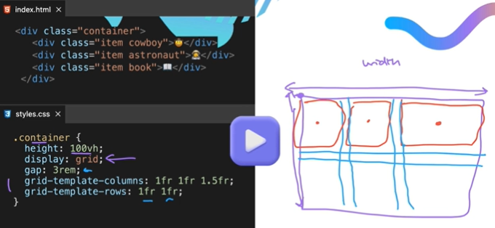

Output of above:

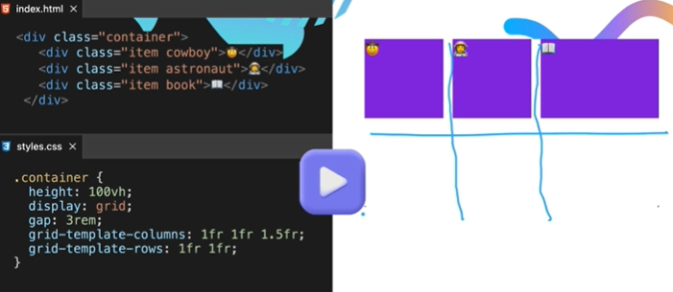

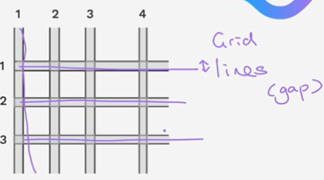

### **Note: Grid property on items:**

gird-column: span 2;

grid-column is combination or a short hand for bellow two commands:

grid-column-start: val1;

grid-column-end: val2;

if we used auto as value here, it’s the initial value, (if nothing specified, it’s 1)

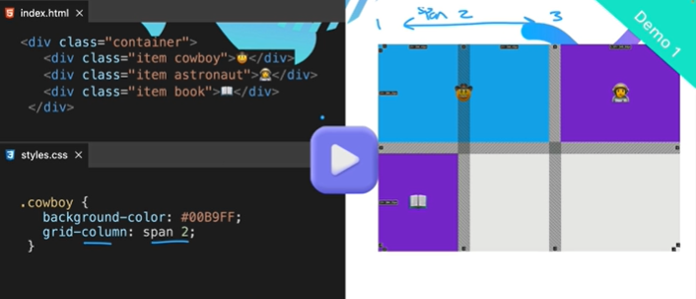

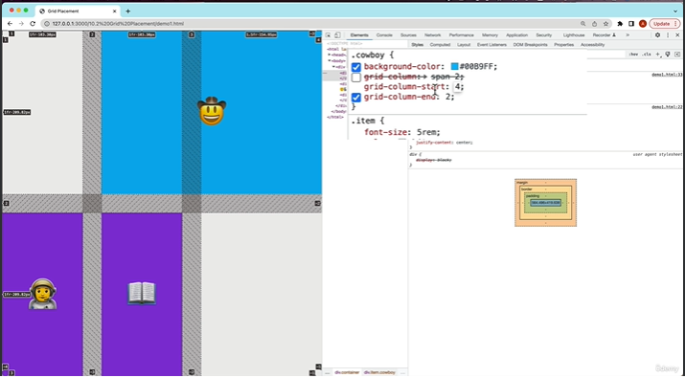

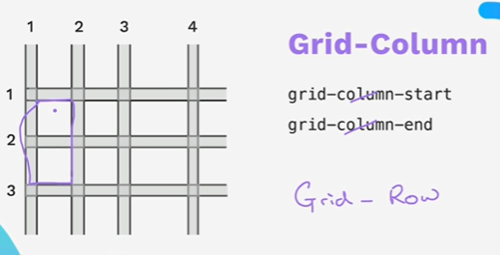

Similar property is grid-Row a combination of two properties as grid-row-start and grid-row-end.

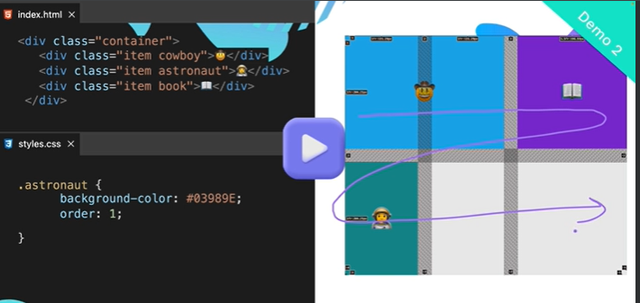

Another way to move astronaut item below is instead of using order:

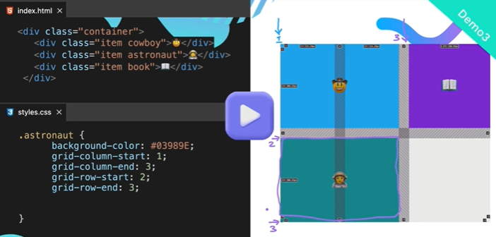

A short-hand of above four coordinates is grid-area property:

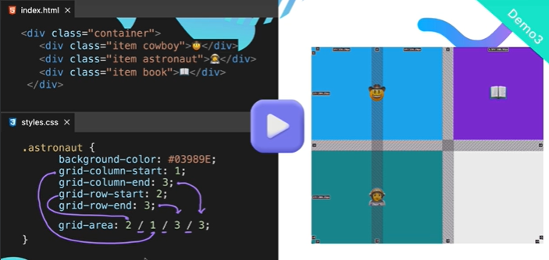

One of the biggest differences between grid and flex box is gid allow overlapping while flex don’t:

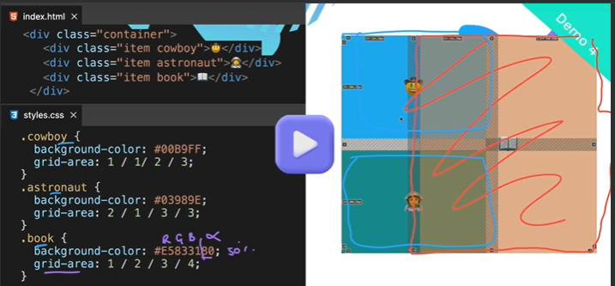

**Grid Exercise:** <https://appbrewery.github.io/gridgarden/>

## **Bootstrap**

It’s an external CSS framework.

(Also called as mobile first website)

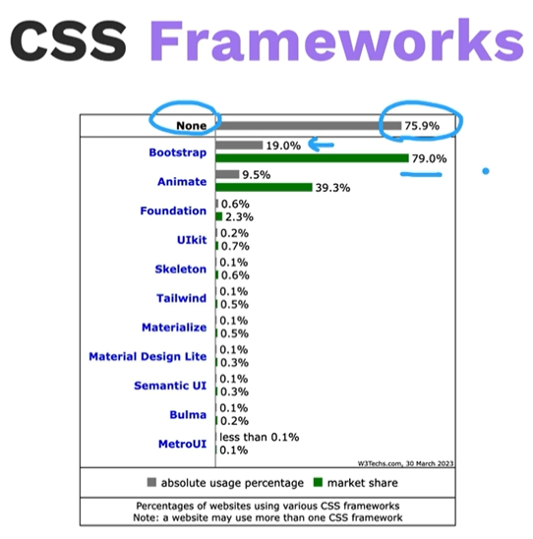

Pros: Easy, prebuild with some pricing plans to build consistent professional look and tested website on different browser which may take edges to build a website for us.

Cons: class-bloat -> html structure should be separate from the CSS, which is not the case in bootstrap.

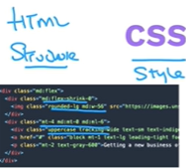

Customization is hard in bootstrap.

### **When to use bootstrap or external CSS framework and when to not.**

When we want quickly to build the mobile first website and it’s ok to not have full control on the layout. We can use bootstrap.

When we want simple layout or very complex custom layout we should not use bootstrap.

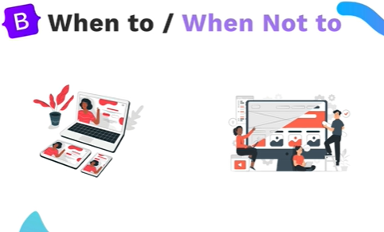

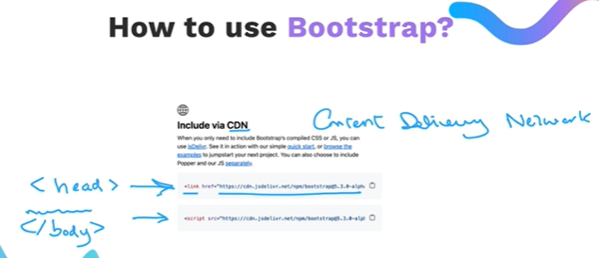

Easiest way to use bootstrap is using CDN link in our html. CDN are hubs across the world to easily load the content which is very close to the user.

https://getbootstrap.com/ to find the style of our webpage.

### **Bootstrap Layout**

Bootstrap has 12 column layout system.

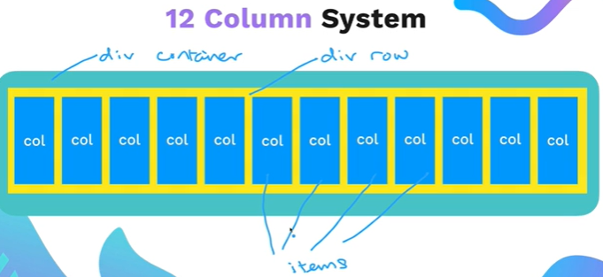

How does it look in code:

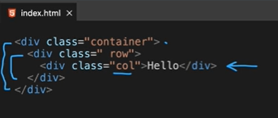

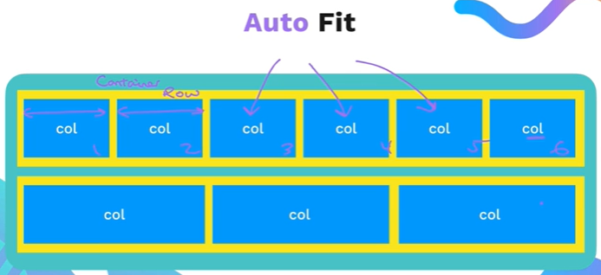

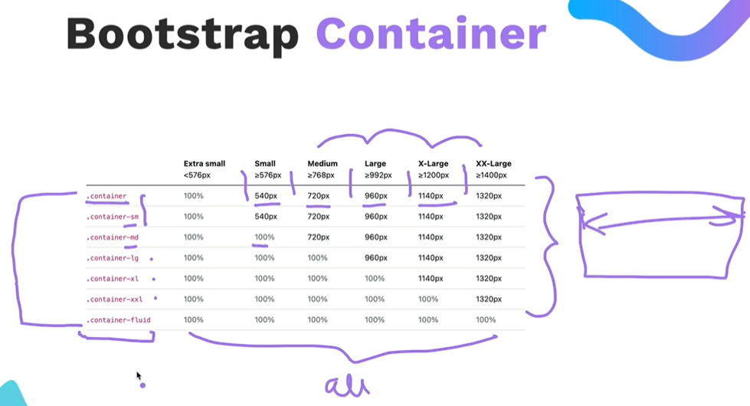

Most used are .container and .container-fluid

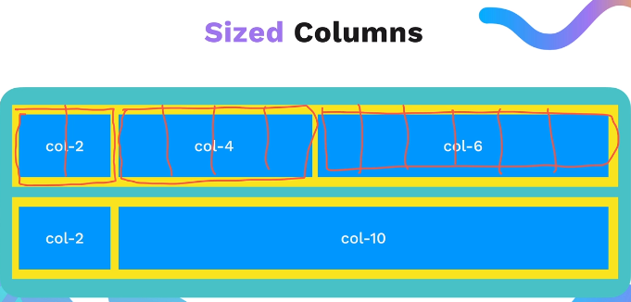 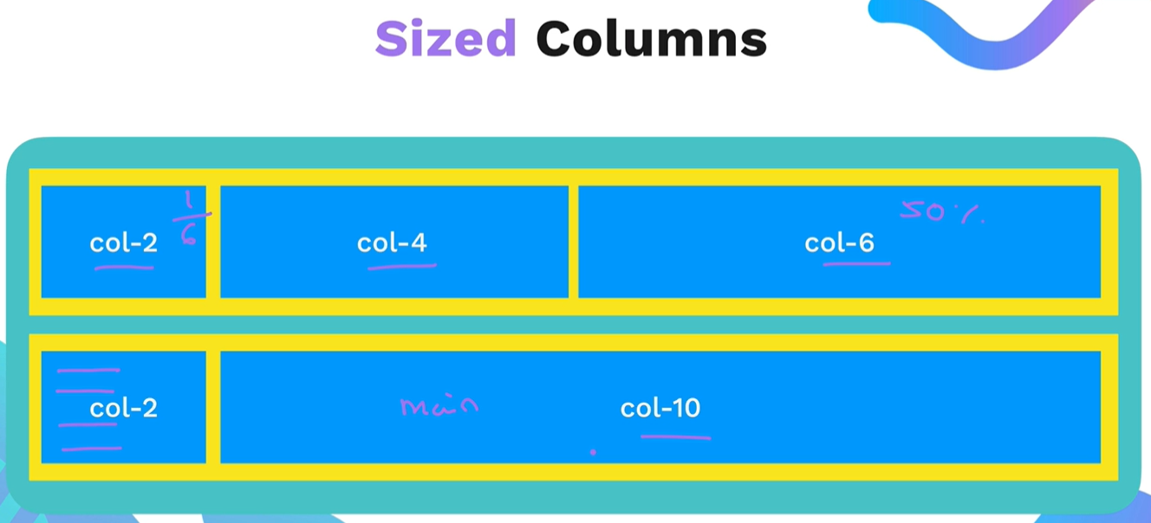 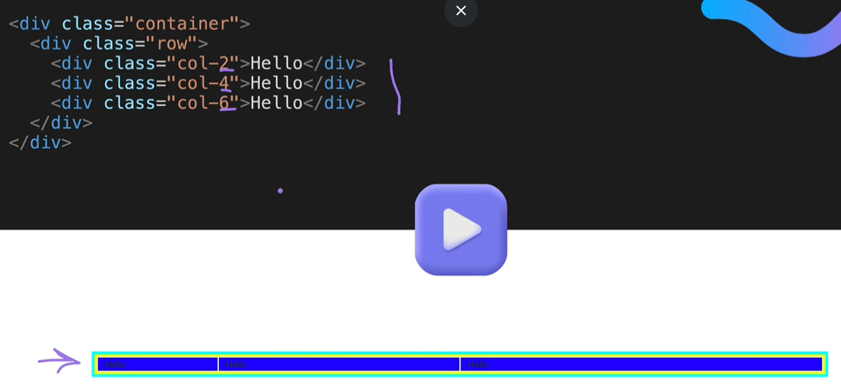

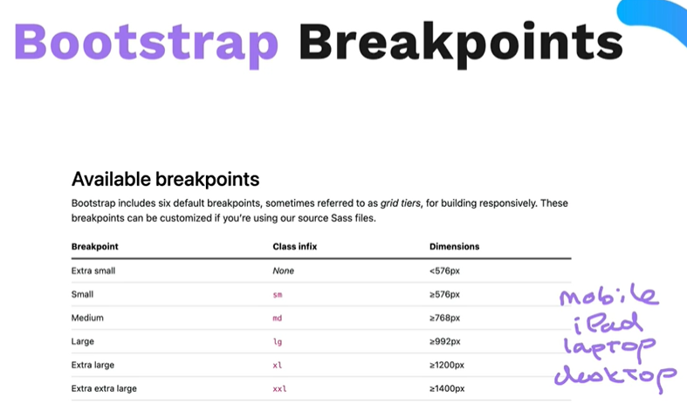

XS may be for foldable devices or devices with narrow screens.

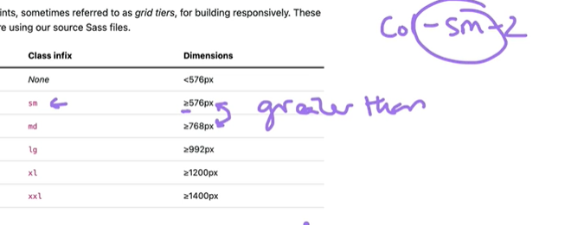

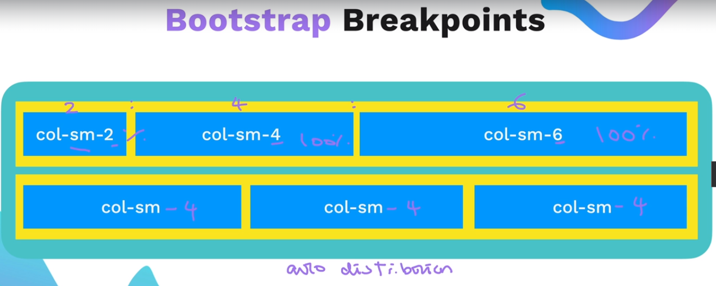

For less then mobile size

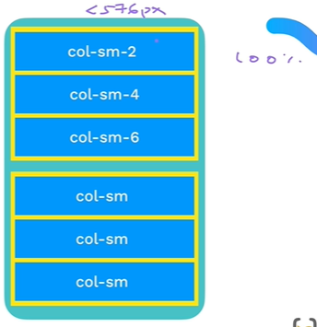 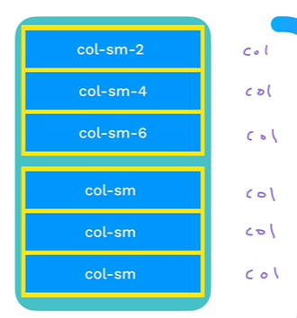

Multiple brackpoint on a single div:

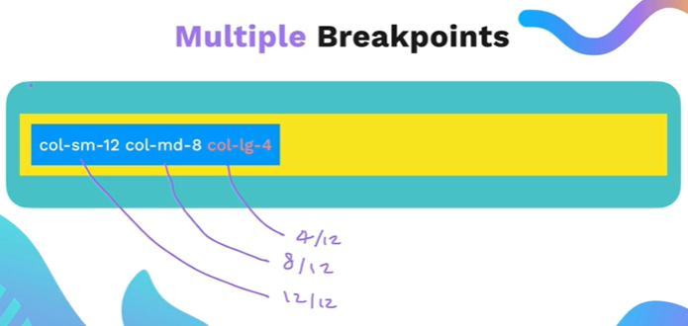

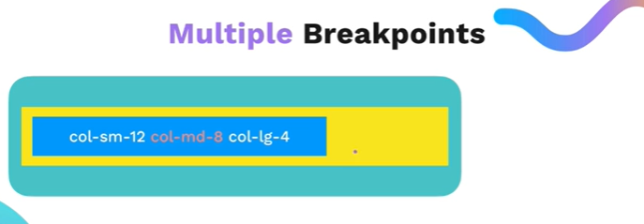 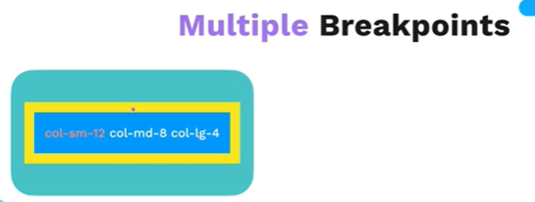

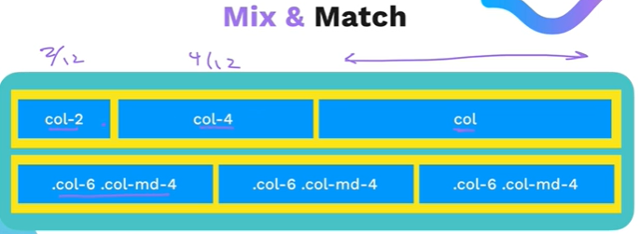

### **Bootstrap layout Exercise:**

<https://appbrewery.github.io/bootstrap-layout/>

Build a website using examples and Docs components on <https://getbootstrap.com/docs/5.3/getting-started/introduction/>

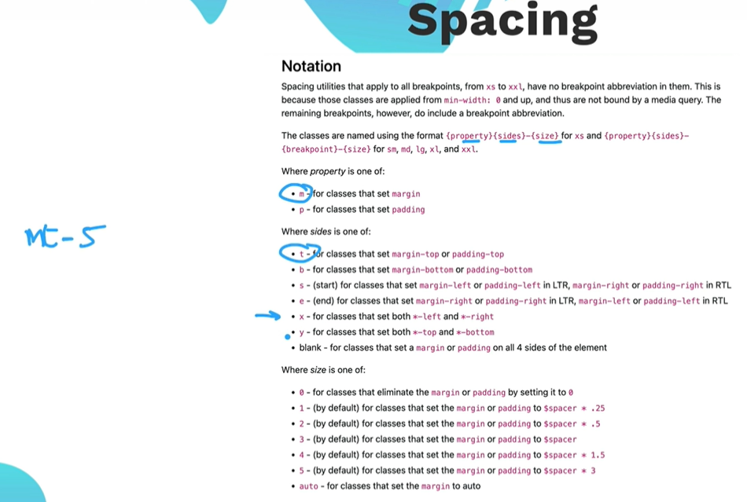

<https://www.w3schools.com/bootstrap/bootstrap_templates.asp>

Bootstrap exercise: <https://appbrewery.github.io/tindog/>

<https://codepen.io/P1N2O/details/pyBNzX> for background color of our exercise.

### **Bootstrap Notes:**

class: container, container-sm, container-md, container-lg, container-xl, container-xxl, container-fluid

class: row

class: col-num

class: col-size-num (size - none, sm, md, lg, xl, xxl)(num-1 to 12)

spacing in bootstrap:

m-margin

p-padding

t-top

b-bottom

x-left and right

y-top and bottom

etc

# **Introduction of Web Design**

1. Understanding color theory
2. Understanding Typography and how to choose a font
3. Manage Attention with effective user interface(UI) design
4. User experience (UX) Design

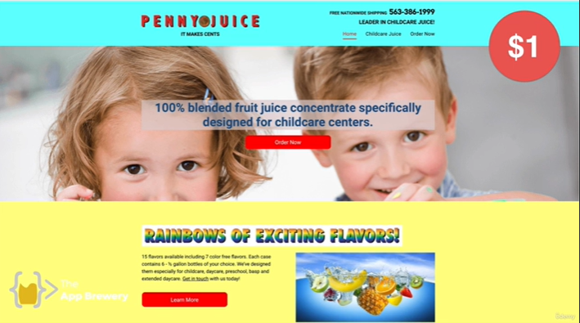

**Vs**

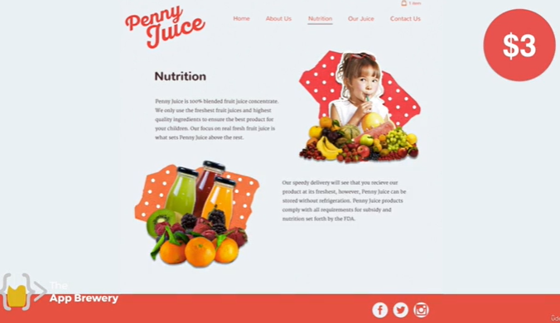

**Understanding color theory:**



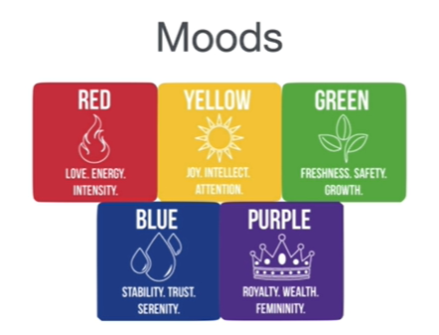

Using right mood of color and have good combination like next color in the choose color from chart gives better looks in sense of color combination:

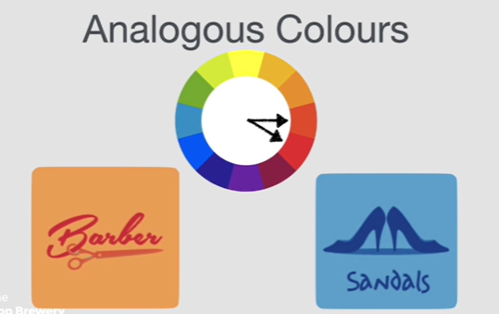

But to make it standout use opposite colors from color palette:

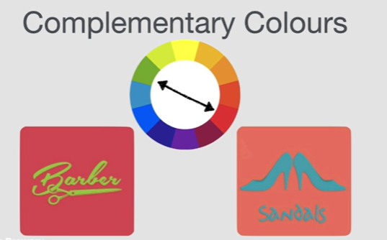

No while using text:

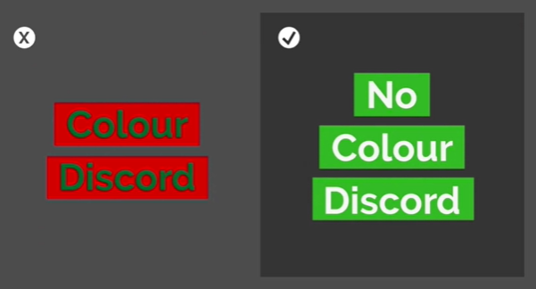

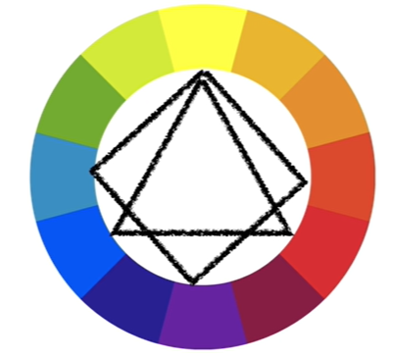

To choose the color:

<https://colorhunt.co/>

<https://color.adobe.com/create/color-wheel>

**Understanding Typography and how to use a Font**

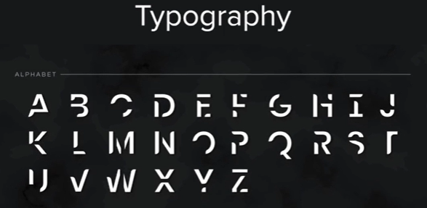



Serif**:**

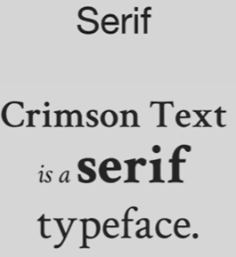

Serif family is further divided into: old style, transitional, modern and slab-sarif

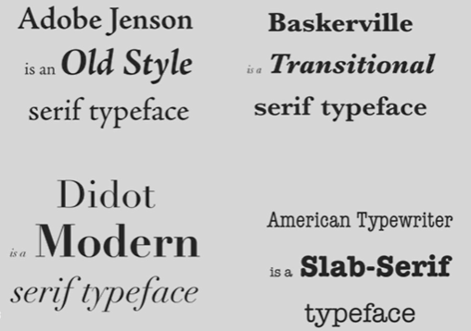

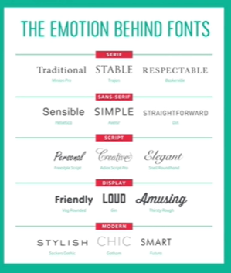

Sub-family of sans-sarif:

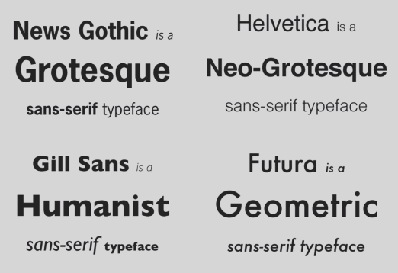

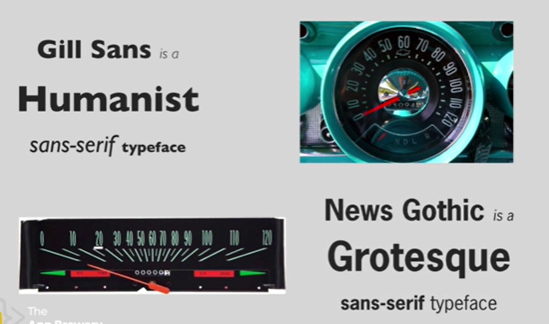

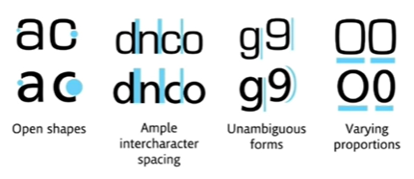

Sticking to just 2 fonts is recommended for web-sites, banners.

Similar era, mood and contrast fonts are recommended:

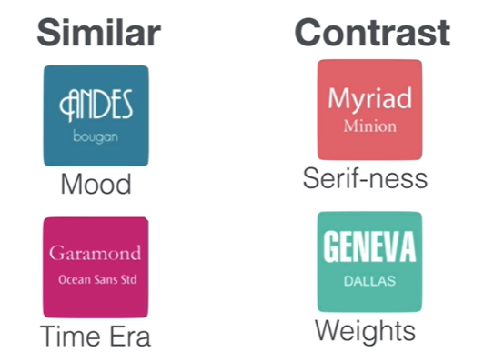

Don’t use this 6 fonts:

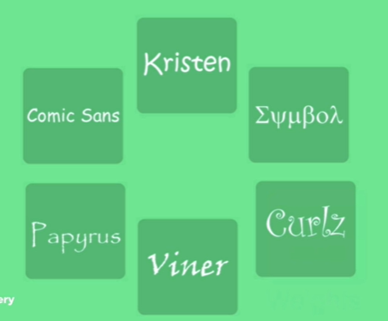

Manage **ATTENTION** with effective UI design:

Hierarchy, Layout, Alignment, White-space, Audience

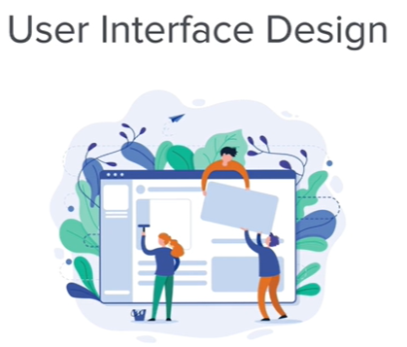

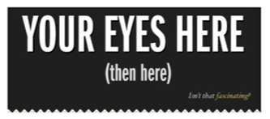

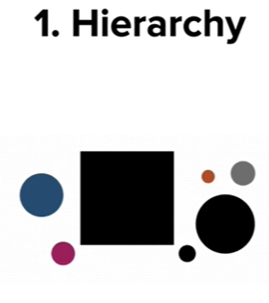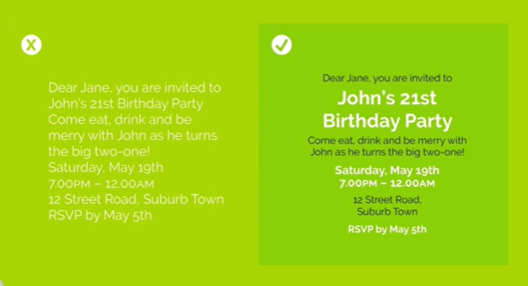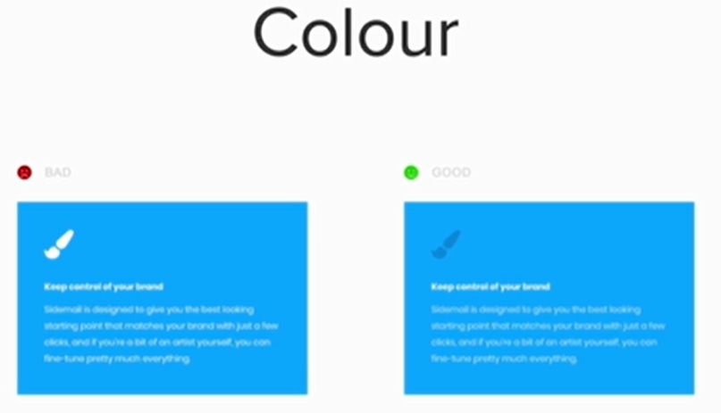

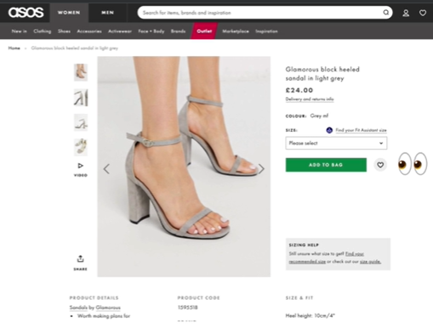

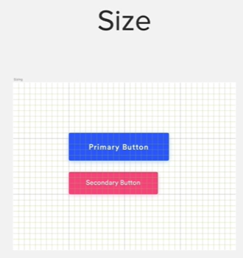

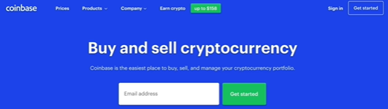

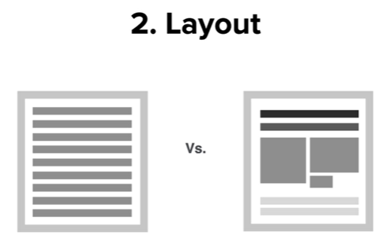

Bad Design example: Wikipedia. Good design example is Grammarly.

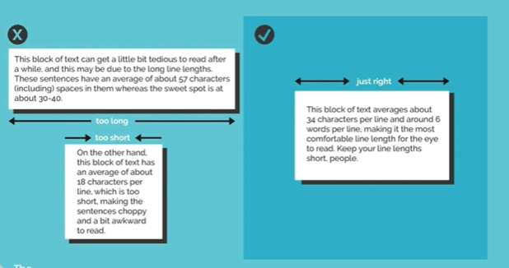

40-60 char per line is better than more or less as shown above.

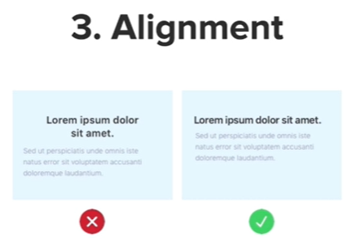

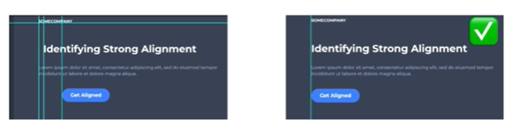

Second in above looks better because all contents are aligned in one line

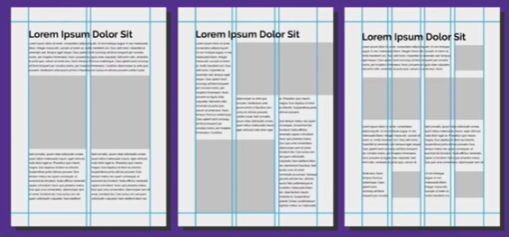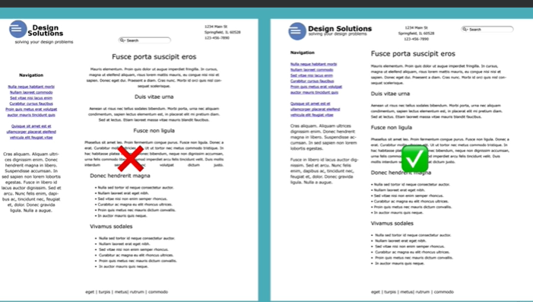

One more important concept is white Space:

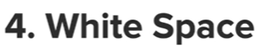



Vs



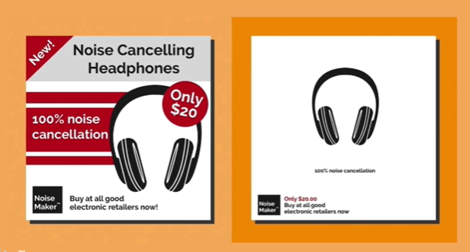

Audience:

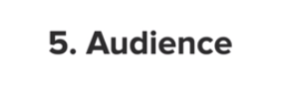

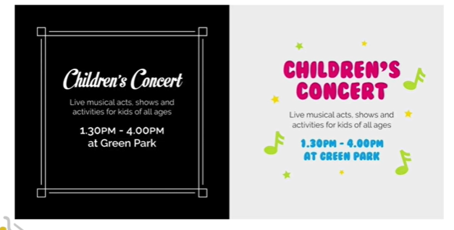

User experience (UX) design:

1. Simplicity.
2. Consistency
3. Reading Pattern – use F or Z layout.
4. All Platform Design
5. Don’t use ur power for Evil

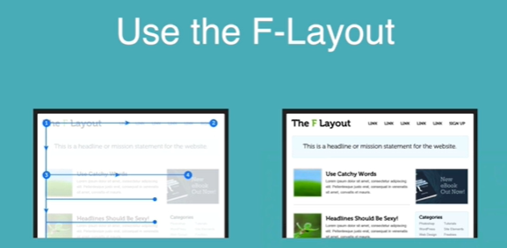

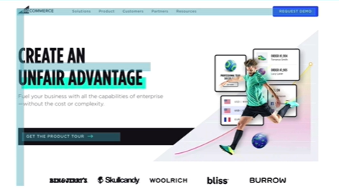

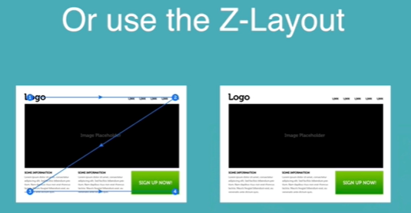

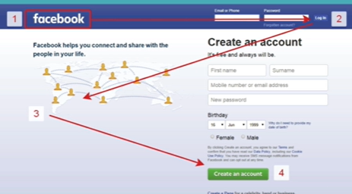

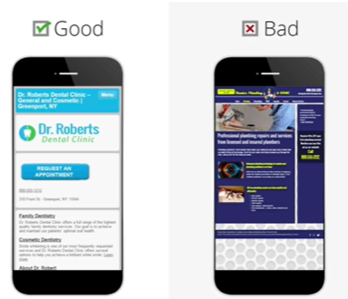

## **Some useful cites:**

<https://www.dailyui.co/>

<https://collectui.com/challenges>

<https://www.canva.com/>

After sign-up choose 1400 to 800 px

# **JavaScript**

**Var** is keyword used to define a variable in javascript, and naming convention is same as the java variable naming convention, start allowed a-z, _,$ than numbers and A-Z can come. Camel Casing is used.

**String concatenation**: + sign is used. Eg. “a”+” ”+”b”= a b

**String length**: word.length;

**Commenting** is same as java: // and /**/

**slice**() method: same as substring of java

**Arithmetic operations** are same as java. Like a++, a--, a+=1;

**function keyword** is used create functions in javascript :

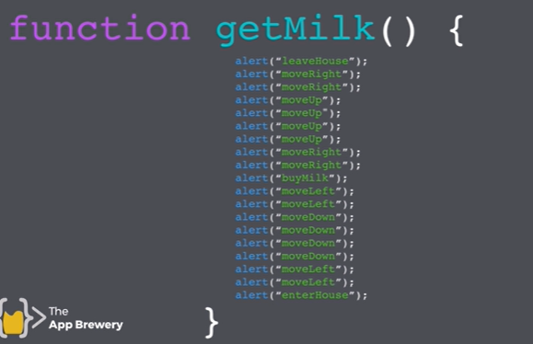

Naming a function has same rules as naming a variable.

**return** is same as java except no need to tell the function that it’s returning something, but if function has a return statement in it, it will simply return the value.

Java script exercises of functions: <https://stanford.edu/~cpiech/karel/ide.html>

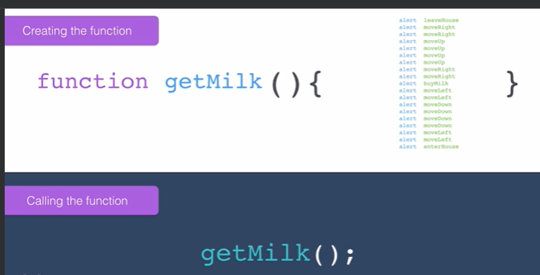

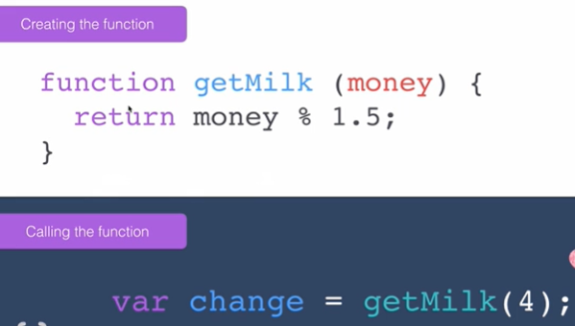

Math.random: generates random numbers from 0 to 0.9999999999999999

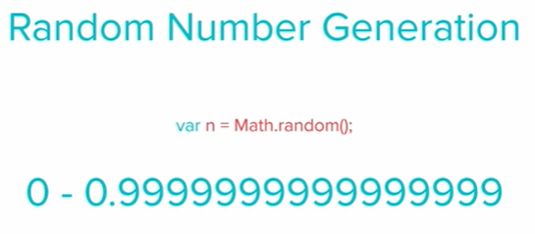

Operators in javascript: ==, ===, !==, >, <, >=, <=

Conditional operators in javascript: &&, ||

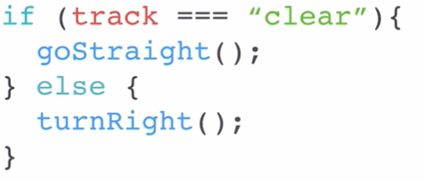

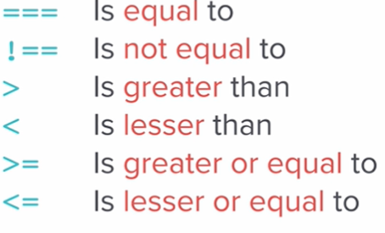

var a = 1;

var b = "1";

typeof(a);

typeof(b);

if(a==b){

console.log("are equal by value");

}else{

console.log("are not equal by value");

}

if(a===b){

console.log("are equal by value and type");

}else{

console.log("are not equal by value and type");

}

**Note**: == in javascript is comparison by value.

=== in javascript is comparison by value as well as datatype.

**typeof**(val) method is used to get the type of variable.

function isLeapYEar(year) {

if(year%4===0){

if(year%100 === 0){

if(year%400 === 0){

console.log("is a leap year");

}

}else{

console.log("is a leap year");

}

}else{

console.log("is not a leap year");

}

}

isLeapYEar(prompt("enter year"));

**Flow chart creator**: <https://app.diagrams.net/>

Leap year: <https://www.youtube.com/watch?v=xX96xng7sAE>

Known leap year: <https://www.mathsisfun.com/leap-years.html>

## Collections:

var a = [1,2,1,3];

Exercise: create a fizz, buzz, fizz-buzz function, printing 1 to 100, for every number divisible by 3 print fizz, by 5 print buzz and divisible by both 3 and 5 print fizz-buzz, do it without using loop.

**push** is method for putting a value in collection and **pop** is removing a value from it.

**includes** is for checking if a value is present in the collection.

## Loops:

while and for loops are used same as java in javascript for iteration. Ex. FizzBuzz example:

var names = ["Pooja", "Vishal", "Niya", "Mumma", "Papa", "Billu"];

console.log(names);

var random = Math.floor(Math.random() * names.length) + 1;

console.log(" who will buy lunch today: "+names[random]+"!");

var collectionsOfNum = [];

var count = 1;

function fizzbuzz(){

if(count%3 === 0 && count%5 === 0){

collectionsOfNum.push("fizzbuzz");

}else if(count%3 === 0){

collectionsOfNum.push("fizz");

}else if(count%5 === 0){

collectionsOfNum.push("buzz");

}else{

collectionsOfNum.push(count);

}

count++;

}

var iterate = 0;

while(iterate <=99){

fizzbuzz();

iterate++;

}

console.log(collectionsOfNum);

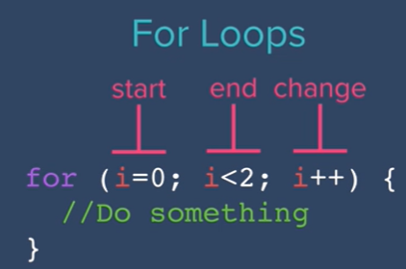

var febSeries = [];

fibonacciGenerator(8);

console.log(febSeries);

function fibonacciGenerator(num){

if (num >= 1){

febSeries.push(0);

}

if (num >= 2){

febSeries.push(1);

}

for(var i = 3; i <= num ; i++){

febSeries.push(febSeries[febSeries.length-2] + febSeries[febSeries.length-1]);

}

}

Exercise 1: Lyrics of the song 99 Bottles of Beer.

Exercise 2: Fibonacci series Generator.

## Javascript to Websites:

Javascript to websites can also be put in HTML in similar way as CSS.

1. Inline:

ex. onload = “alert(“Hello”)”; here “” will need to be ‘’ as it confuses the browser.

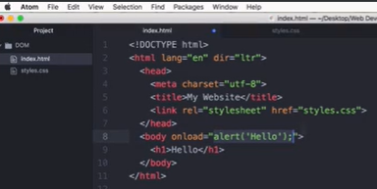

1. Internal:

Ex. <script type=”text/javascript”>

alert(“Hello”);

</script>

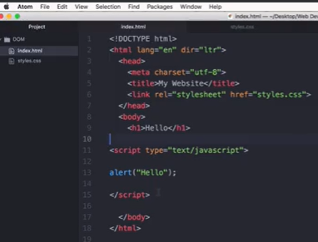

1. External: it should be the last line in HTML just before closing body take unlike CSS external declaration in the head section. As CSS needs first hand loading while to run javascript it needs HTML to be known to browser first.

Ex. <script src=”location of js file” charset=”utf-8”></script>

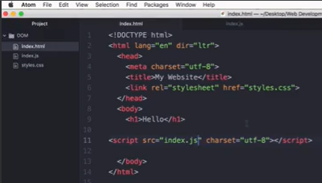

## **Document Object Model (DOM):**

DOM is used by browser to catalog the HTML.

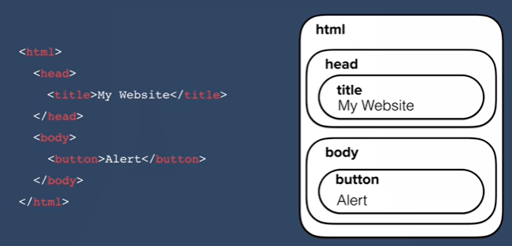

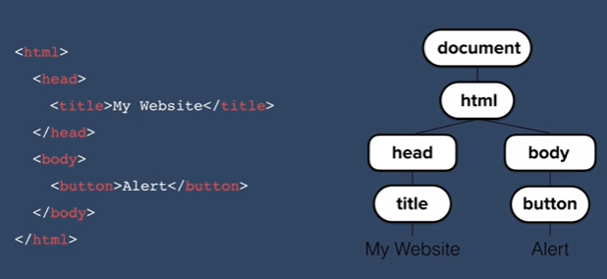

HTML tree generator chrome extension: <https://chromewebstore.google.com/detail/html-tree-generator/dlbbmhhaadfnbbdnjalilhdakfmiffeg?pli=1>

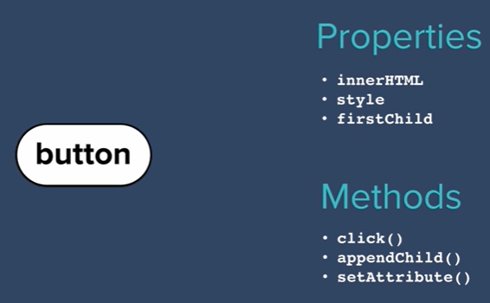

Each element in HTML is object as per DOM and it has properties and methods.

We can set and get this property using javaScript.

We can select any element of HTML through DOM and manipulate them:

<https://www.w3schools.com/jsref/prop_style_backgroundcolor.asp>

select can be done as direct element, but most easy it is done as:

document.querySelector("button");

in querySelector we can select element as as in CSS we select element using hierarchy, id, class etc.

## **Separation of Concern:**

Keep structure to HTML, styles to CSS and dynamic behaviour to javascript.

To do so we can create new class in CSS with specific style we want to apply to any element.

And in javascript code we can add/remove/toggle that class to the classList of the element selected.

Ex.

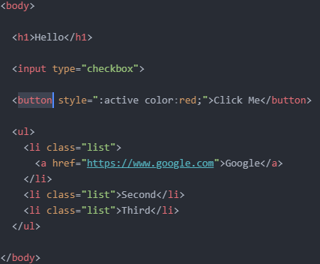 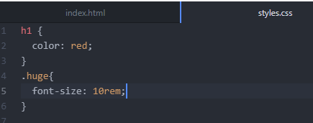

And in javascript document.querySelector("h1").classList.add("huge");

innerHTML and textContent:

for tag:

<h1><strong>Hello</strong></h1>

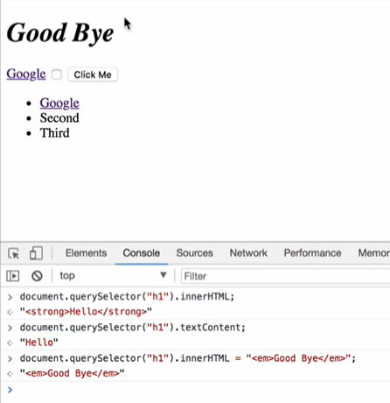

We can manipulate HTML attributes like href, class, src etc (other then tag other things are attribute in html), we can get/set it like:

Document.querySelector(“a”).getAttribute(“href”);

Document.querySelector(“a”).setAttribute(“href”, “https://bing.com”);

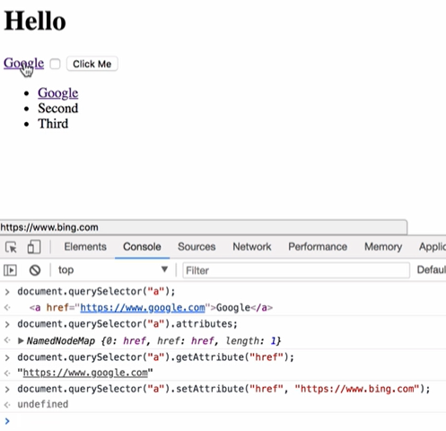

My first java script file:

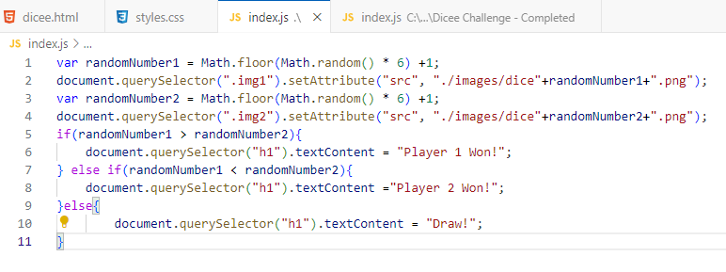

document.querySelector(“element”).addEventListener(“event”, function);

here event are the events we can perform on an html elements, common events can be found on:

<https://developer.mozilla.org/en-US/docs/Web/Events>

function can be normal or anonymous as:

function onClick(){

alert(“Clicked”);

}

Or

document.querySelector(“button”).addEventListener(“click”, function (){alert(“Clicked”);});

**this keyword:**

referring the object itself.

var numOfButtons = document.querySelectorAll(".drum").length;

for(var i=0; i < numOfButtons ; i++){

document.querySelectorAll(".drum")[i].addEventListener("click", function (){

this.style.color = "white";

});

}

**Higher Order Functions:**

The functions which takes another functions as an input are higher order functionss.

Note: how we can call a function from another function in below snapshot.

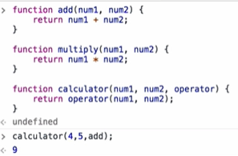

**Objects in javascript:**

var houseKeeper1 = {

name: "Dimy",

age: 25,

experience: 2,

type: ["room cleaning", "bathroom cleaning"]

};

var houseKeeper2 = {

name: "Jimy",

age: 35,

experience: 10,

type: ["room cleaning", "bathroom cleaning", “lobby”]

};

Using **Constructor Function**, we can create objects easily instead of writing all one by one like above.

Constructor Functions are functions but it’s name starts with capital letter instead of small letter as of normal function and it takes inputs and we match the inputs with the property names of our object.

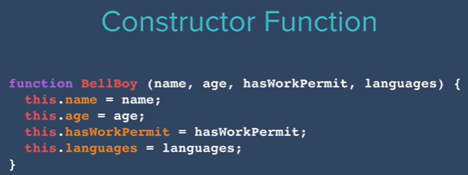

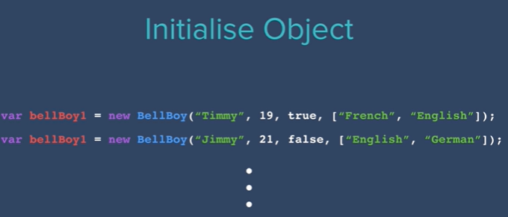

**switch case**: it is same as java

**methods in java-script**: If a function is attached to an object is a method

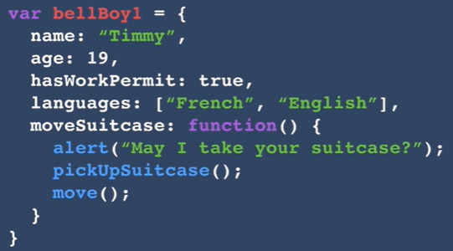

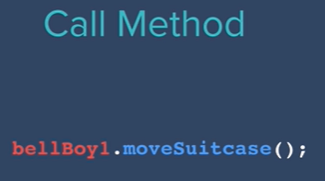

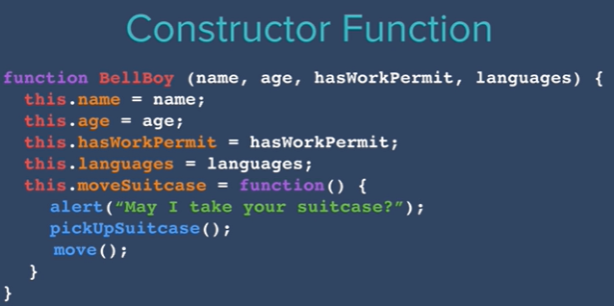

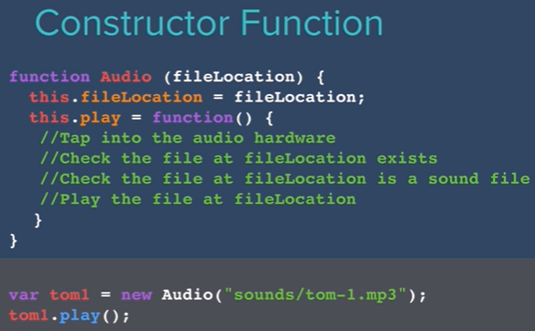

Use of another event “keydown” of keyboard:

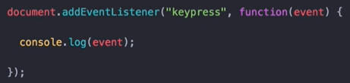

Here, addEventListener will be linked to whole document as the keyboard keys can’t be linked.

**Understanding Callbacks and how to respond to Events:**

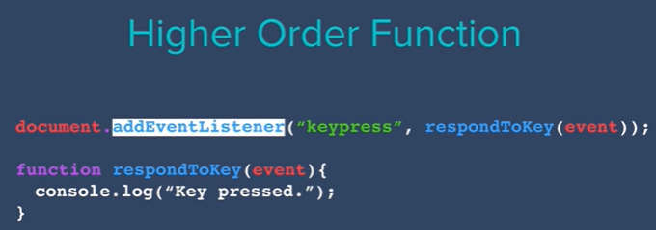

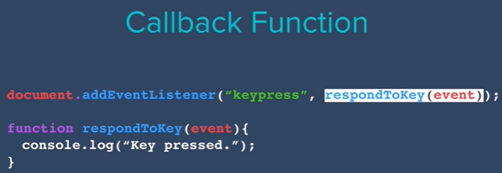

Understanding CallbackFunction:

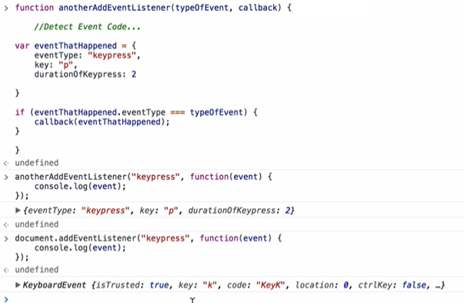

To enter into debug mode in chrome.

Just type **debugger**; on it’s console:

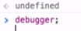

# **JQuery**

Most popular java-script library.

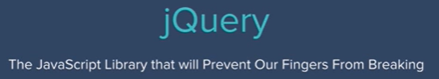

Syntax:

jQuery(“h1”) or $(“h1”)

to include it in our project, go to <https://jquery.com/> -> download -> CDN -> google CDN

CDN stands for Content delivery network, which is fastest way to download and cache jquery or bootstrap from nearest network. Best to use the most popular one so use Google.

Select and add the latest version of script:

<script src="https://ajax.googleapis.com/ajax/libs/jquery/3.7.1/jquery.min.js"></script> just before our java-script tag in html which is just before end of body tag.

Or use code as bellow to check if it is ready to be used in js file in case u have decided to keep the script tag in head section:

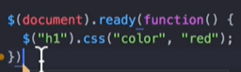

javascript code:

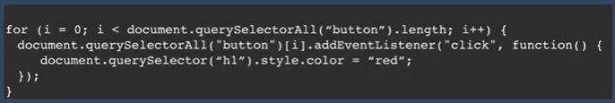 to jquery code:

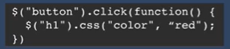

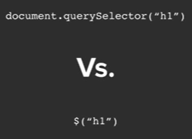

To minify the js or css code:

<https://www.minifier.org/>

in jquery to select an element like in java-script:

document.querySelector(“h1”) we can just write $(“h1”)

even for multiple: document.querySelectorAll(“button”) we can just write $(“button”) will select all buttons.

Manipulating Styles with JQuery: use css as: single value in css is get and two values in it is set.

Ex.

$(“h1”).css(“color”,”red”);

console.log($(“h1”).css(“color”));

To separating the concern:

Use: addClass or removeClass

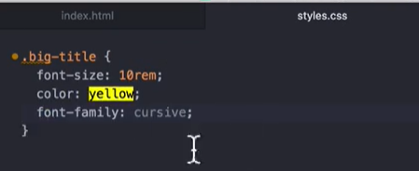

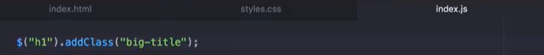

To add two classes:

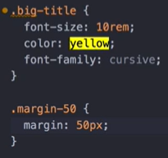

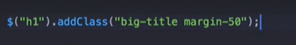

hasClass in jQuery

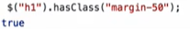

Manipulating text with jQuery: ex. $("h1").text("Bye").html("<em>Hey</em>");

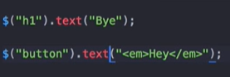

Manipulating attributes with jQuery:

Get -> 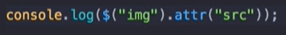

Set -> 

$(“h1”).attr(“class”) ;

Adding Event Listeners with jQuery:

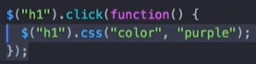

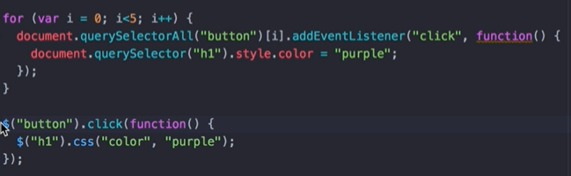

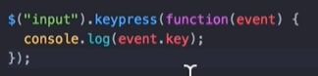 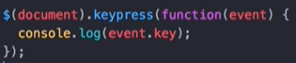

Challenge: change text on each keystrock ->

$(document).keydown(function(event){

$("h1").text(event.key);

});

For adding event listener in jQuery we can also use on mentod as below or event methods as above:

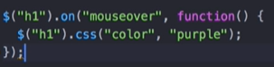

Using jQuery we can update html on the fly:

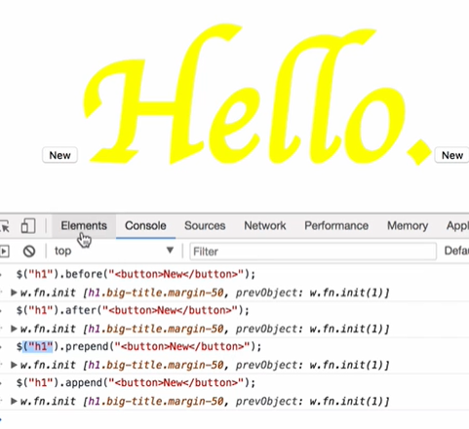

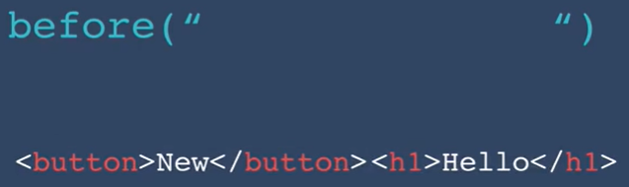 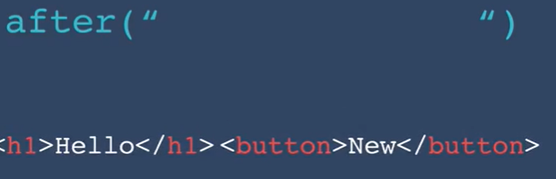

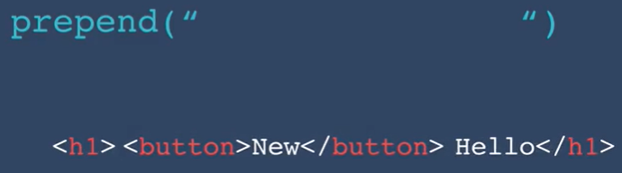 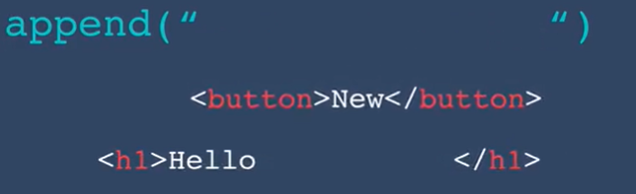

Remove method:

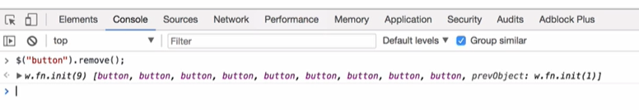

hide(), show(), toggle(), fadeout(), fadeIn(), fadeToggle(), slideUp(), slideDown(), slideToggle(), animate() methods:

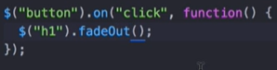

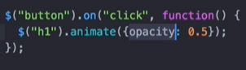

**With animate we can only use all css with numeric value**. 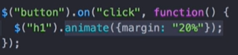

Channing methods in jQuery:

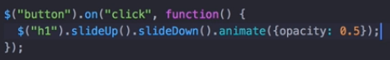

# **The Unix Command Line**

## Some unix commands

1. mkdir
2. ls
3. cd
4. cd ~ -> go to root directory.
5. Up arrow -> to go to previous commands
6. Down arrow -> to go to further commands
7. cd.. -> go to parent folder
8. Alt + click /left or right arrow -> go to a particular position if want to edit some command.
9. ctrl + A -> go to start of text, if want to edit some command.
10. ctrl + E -> go to end of text, if want to edit some command.
11. ctrl + U -> clear cmd
12. touch filename-> create a file
13. start filename-> open a file
14. code filename-> open a file with a particular editor, in this case VS code
15. rm filename -> remove file
16. rm * filename -> remove all files
17. pwd -> shows current path
18. rm -r -> remove dir
19. <https://www.learnenough.com/command-line-tutorial> some more helpful commands.

# Node.js

## Definition:

An asynchronous event-driven JavaScript runtime, Node.js is designed to build scalable network applications.

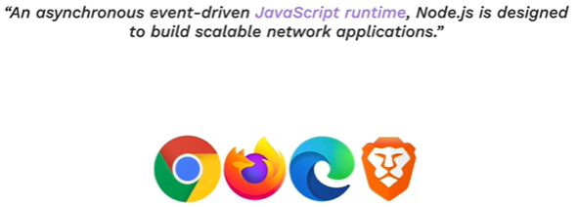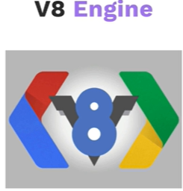

Code comes with V8 engine.

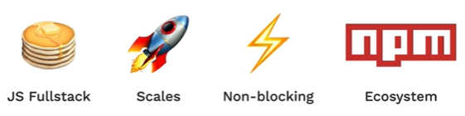

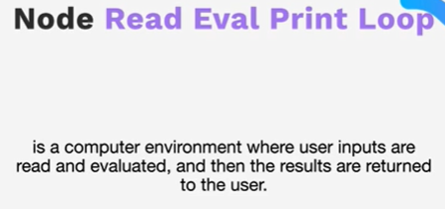 to initiate Node REPL just type command node on terminal.

Use ctrl + C to exit anything on command line.

**Native Node Module:** node js documentation: <https://nodejs.org/docs/latest/api/>

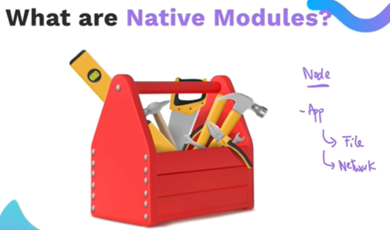

**Note:**  to run a file use command -> node filename -> ex. node index.js

## **NPM – Node package Manager:**

npm comes pre-bundled with node.js, so if node.js is installed you already have npm.

To initialize npm use -> npm init

It will ask couple of configuration details, after entering those a new file “package.json” will be generated in the project.

Now to install a new package we want to use in our project use command “npm install package-name”

To find a package go to <https://www.npmjs.com/> and search for it.

Once it is installed package.json file will be updated. We can use it now.

### **ECMAScript Modules**

CJS stands for common js

ESM stands for EcmaScript modules. From node.js 12 version onwards, every thing like front-end and back-end is standardized for reasons we don’t want to be into, so we can use import instead of require now onwards.

To use import:

Add "type": "module", to package.json

## Express:

Express is a framework on top of Node.js.

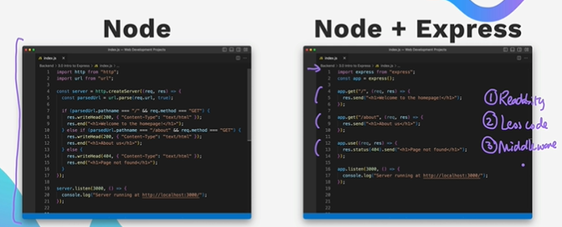

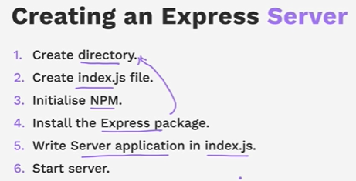 To write server app in index.js use documentation - Express documentation: <https://expressjs.com/en/starter/installing.html>.

To know all the ports running on Windows/Mac:

netstat -ano | findstr "LISTENING"

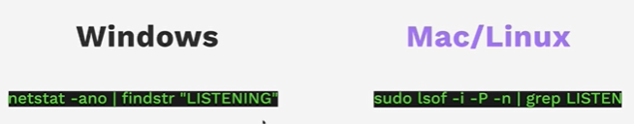

import express from 'express';

const app = express();

const port = 3000;

app.listen(port, () =>{

    console.log(`My App listening to the port ${port}`);

});

### HTTP Request:

Hyper text transfer protocol.

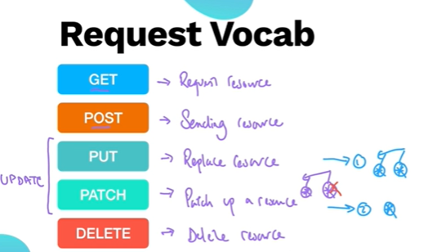 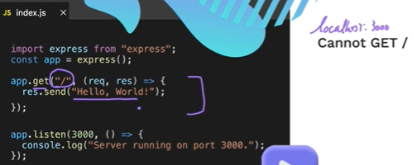

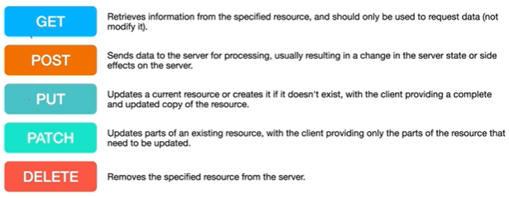

How to properly close a port:

<https://dev.to/sylwiavargas/how-to-properly-close-a-port-2p36>

To avoid restarting server manually after each file change, use **nodemon** index.js run command instead of node index.js. We need to install it for our project or globally like:

npm i -g nodemon

<https://stackoverflow.com/questions/63211819/nodemon-command-not-working-unauthorized-access> for help if nodemon index.js don’t work.

<https://developer.mozilla.org/en-US/docs/Web/HTTP/Status>

## **HTTP response status codes**

HTTP response status codes indicate whether a specific [HTTP](https://developer.mozilla.org/en-US/docs/Web/HTTP) request has been successfully completed. Responses are grouped in five classes:

1. [Informational responses](https://developer.mozilla.org/en-US/docs/Web/HTTP/Status#information_responses) (100 – 199)
2. [Successful responses](https://developer.mozilla.org/en-US/docs/Web/HTTP/Status#successful_responses) (200 – 299)
3. [Redirection messages](https://developer.mozilla.org/en-US/docs/Web/HTTP/Status#redirection_messages) (300 – 399)
4. [Client error responses](https://developer.mozilla.org/en-US/docs/Web/HTTP/Status#client_error_responses) (400 – 499)
5. [Server error responses](https://developer.mozilla.org/en-US/docs/Web/HTTP/Status#server_error_responses) (500 – 599)

HTTP return codes cheat sheet:

1**. Hold on

2**. Hear you go

3**. Go away

4**. You fucked up

5**. I fucked up

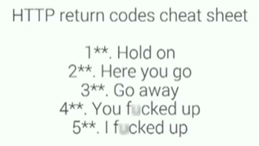

If dependency is specified in package.json file and node_modules are not present. Run npm install command.

## **Introduction to Middleware:**

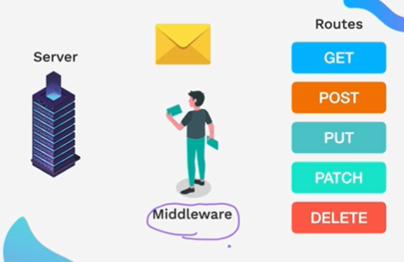 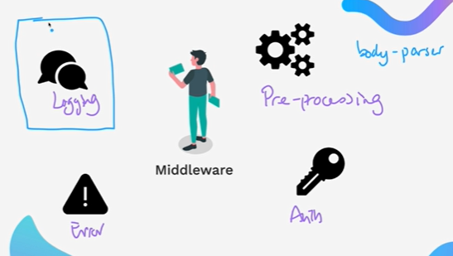

Middleware are used for pre-processing, logging, authentication and identify and process errors before they got to handlers (get, post, put, patch, delete).

Body parser is type of pre-processing middleware.

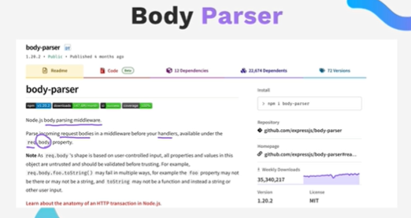

Most commonly used middleware in Node and express backend engineering is Body Parser. Used to power request with body as below:

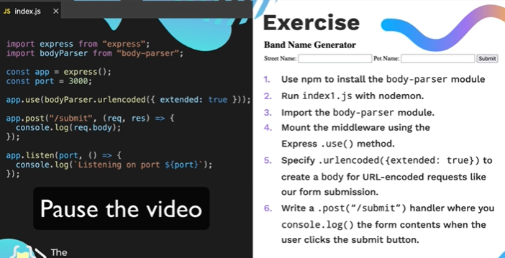

**Morgan:** HTTP request logger middleware for node.js. it logs info like request, time etc. as below:

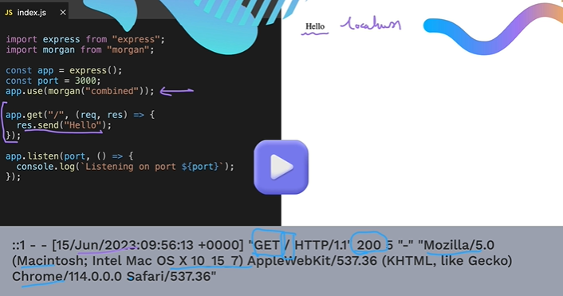

Writing custome middleware:

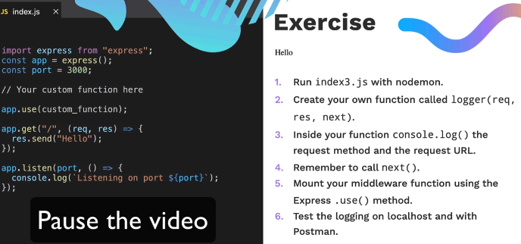

# **EJS: Embedded JavaScript**

After posting request, if we want to render the information we had on the form, how will we render it?

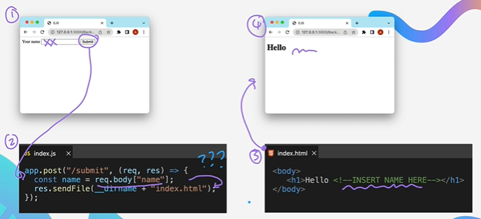

It is done through Templating:

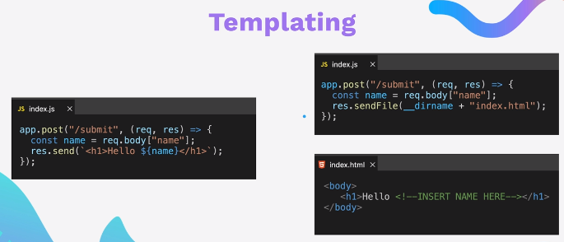

Separation of concern:

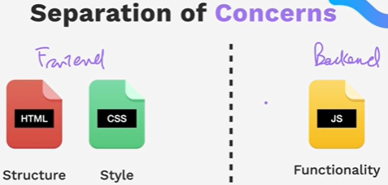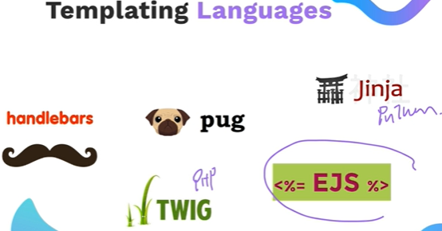

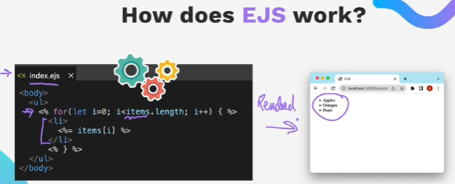

How does EJS work? Using symbols <%%> in ejs file which are html file.

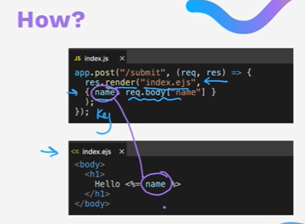

EJS language support plugin has to installed in VS code to support highlighting EJS and it’s suggestions in coding.

## **EJS Tags:**

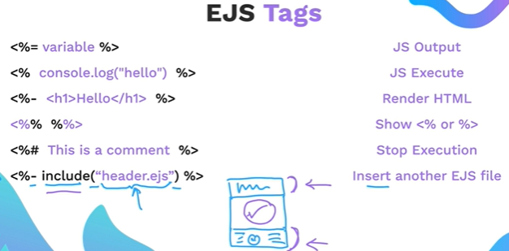

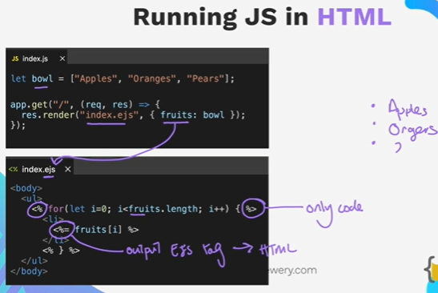

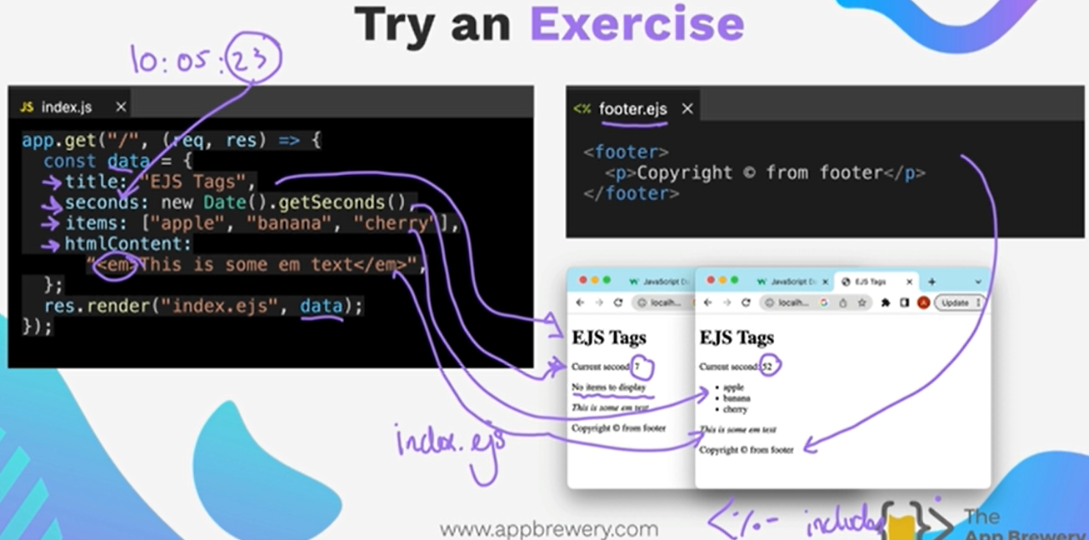

## Passing data to EJS Templates:

Passing data from server to client and from client to server.

Server to Client:

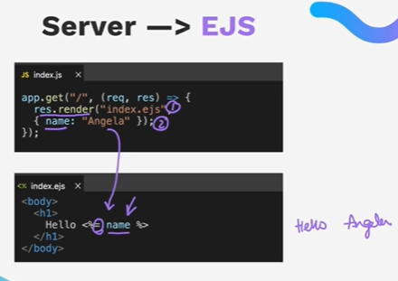

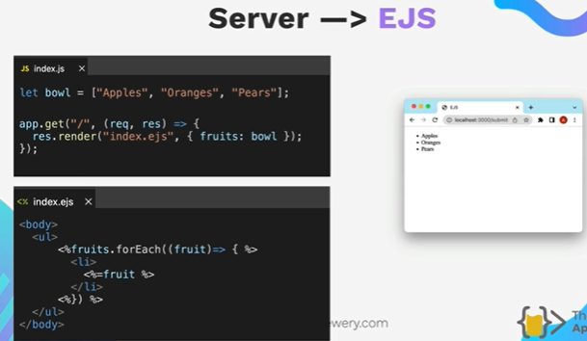

What if there is no Data at server side?

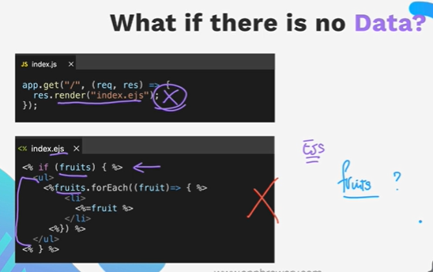

Solution:

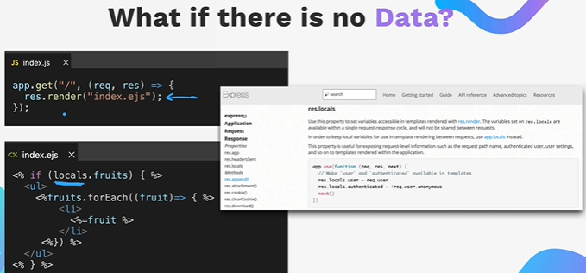

Client to server: using post request and body-parser;

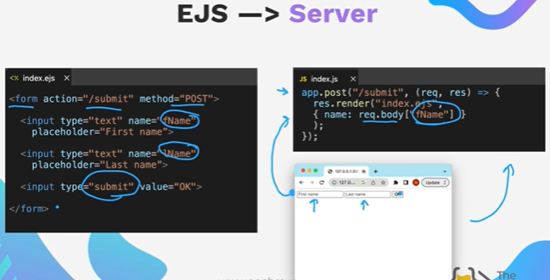

## EJS Partials and Layouts:

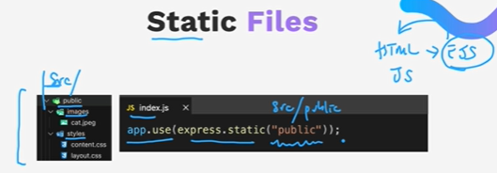

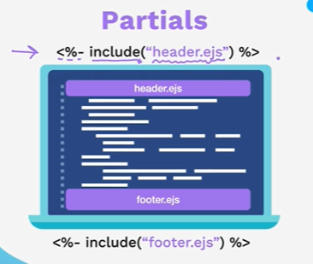

# **GIT**

## Git commands:

1. git init -> initialize git repository in local.
2. git status -> to see status of git.
3. git add -> move file to staging area.
4. git add “file-name”
5. git add . -> add all the files to staging area
6. git commit -m “commit message” -> best practise is to write commit message in present tense.
7. git log -> see git logs.
8. clear -> clear console

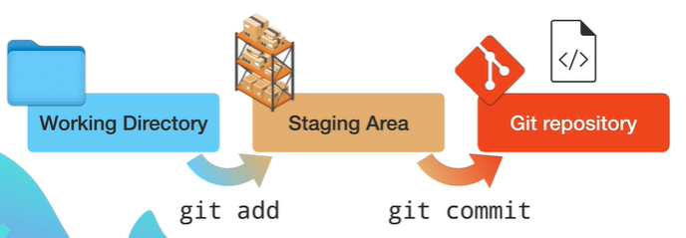

Fig. Git local repository

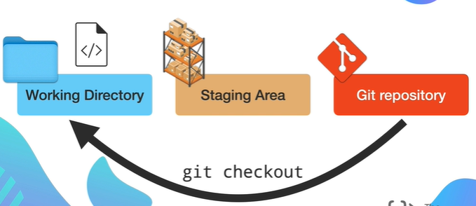

Fig. Git checkout

1. git checkout “file-name” -> to revert local change if we messed up locally with the last committed change.
2. git diff “file-name” -> gives difference between local file changes to last committed one.
3. git rm -cached -r . -> remove all added files from staging area.

## **GitHub and Remote Repository:**

Sign-up or login

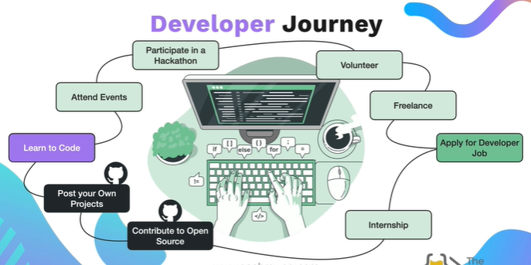

1. create a new repository if it doesn’t exist.
2. git remote add origin url

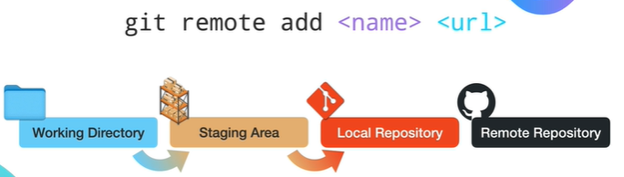

1. git push -u remote-name branch-name

or git push -u origin main or git push -u origin master

note: main is preferred.

here u flag basically links up your remote and your local repository.

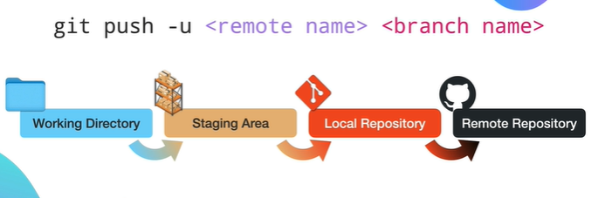

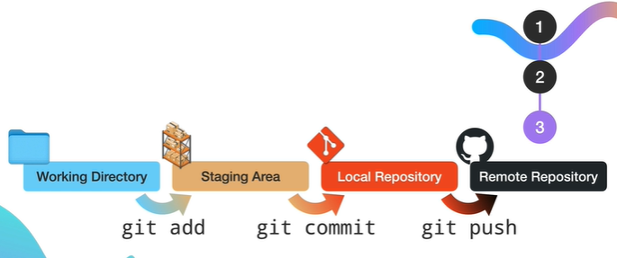

## **Git Ignore:**

Just create a new file named “.gitignore” in the local git tracked project. Open it and write the file names as is to ignore it by git.

You can use *.txt to ignore all the txt files by git, use # for commenting in the “.gitignore” file.

<https://github.com/github/gitignore> a github owned gitignore repository having gitignore template for various projects like java, node etc, we can see and use in our project just by coping it.

## 

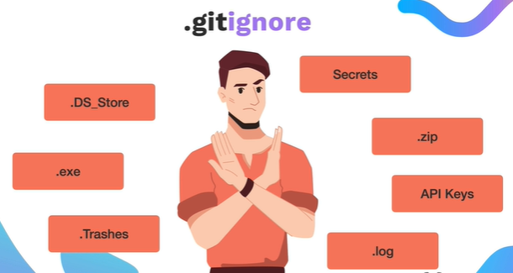 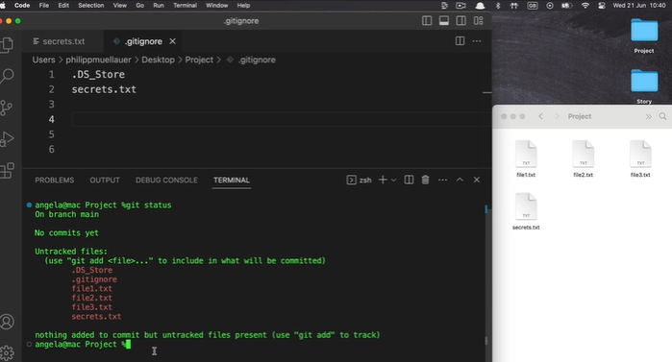

## **Git clone:**

git clone url

url will be copied from github.

You can find open-source projects for beginners for contribution are at:

<https://github.com/MunGell/awesome-for-beginners?tab=readme-ov-file>

some games:

<https://github.com/clupasq/word-mastermind>

<https://github.com/awesome-selfhosted/awesome-selfhosted>

